ALS 3205 Buffering Agents For Cardiac Arrest (OHCA)
Evidence to Decision Table (EtD)

Question
Should buffering agents be used for out-of-hospital cardiac arrest?
Population: | Adults with cardiac arrest
Intervention: | The administration of buffering agents during cardiopulmonary resuscitation
Comparison: | The use of placebo, no buffering agent, or another buffering agent during cardiopulmonary resuscitation
Main outcomes: | Return of spontaneous circulation; survival at hospital admission; survival at hospital discharge, 30 days, or subsequent time points; survival with a favorable neurological outcome at hospital discharge, 30 days, or subsequent time points; health-related quality of life
Setting: | Out-of-hospital
Perspective:
Background:
Conflict of interests: | None applicable

Assessment

Problem
Is the problem a priority?
Judgement | Research evidence | Additional considerations
○ No  ○ Probably no  ● Probably yes  ○ Yes  ○ Varies  ○ Don't know | Buffering agents, particularly sodium bicarbonate, are frequently administered during cardiac arrest despite guidelines recommending against routine use.

Desirable Effects
How substantial are the desirable anticipated effects?
Judgement | Research evidence | Additional considerations
● Trivial  ○ Small  ○ Moderate  ○ Large  ○ Varies  ○ Don't know | Three trials found no benefit from buffering agents on any outcome.  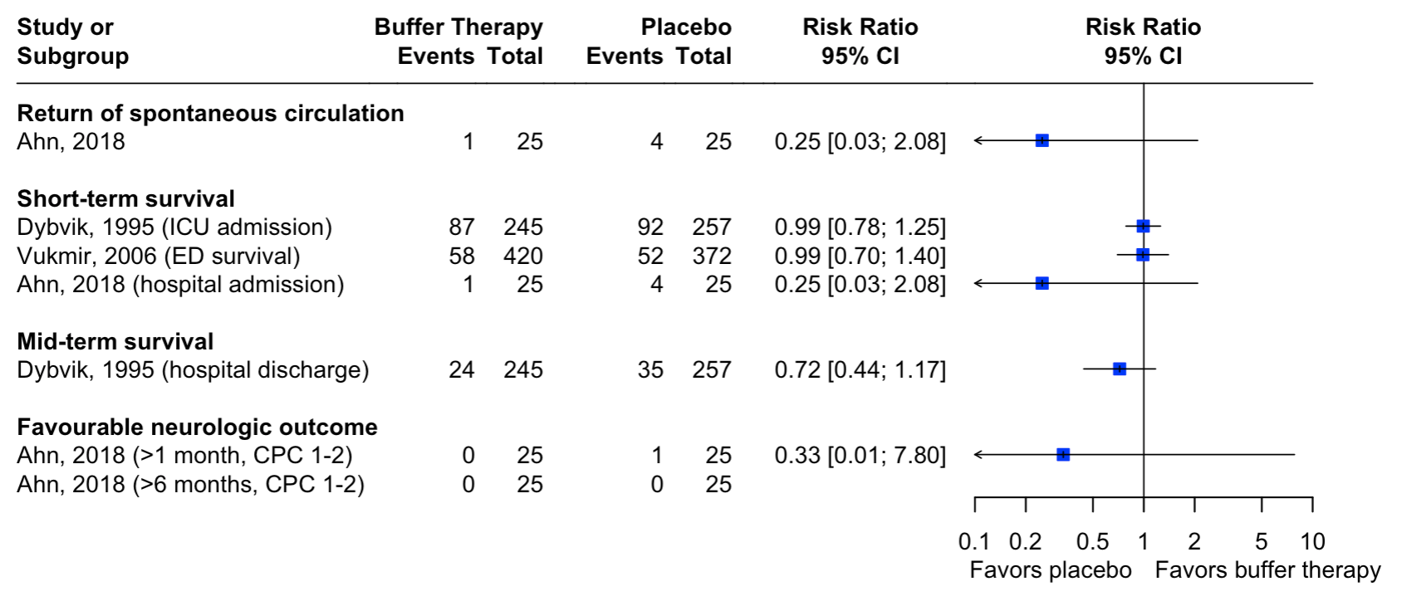  Forest plot of individual trial results: No estimates are pooled. Dybvik et al additionally reported an adjusted odds ratio of 0.77 (95% CI, 0.43 to 1.41) for survival to hospital discharge, adjusted for ventricular fibrillation on arrival, bystander CPR, and dispatch-response interval. Vukmir et al and Ahn et al reported no adjusted estimates.  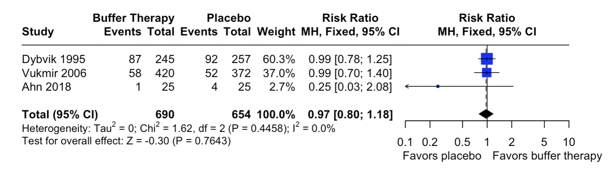  Meta-analysis results: Three studies were analyzed with a total of 690 subjects in the buffer therapy group and 654 subjects in the placebo group. The meta-analysis, using a fixed effect model with the Mantel-Haenszel method, showed no statistical difference between the two cohorts, with an overall risk ratio of 0.97 (95% confidence interval: 0.80 to 1.18).  Note that the endpoint differed across trials. Dybvik et al reported survival to ICU admission, Vukmir et al reported survival to emergency department arrival, and Ahn et al reported survival to hospital admission. Dybvik investigated Tribonat (a combination of sodium bicarbonate, trometamol, and phosphate) rather than sodium bicarbonate alone.

Undesirable Effects
How substantial are the undesirable anticipated effects?
Judgement | Research evidence | Additional considerations
○ Large  ○ Moderate  ○ Small  ○ Trivial  ○ Varies  ● Don’t know | Adverse effects were not systematically reported in the out-of-hospital cardiac arrest trials.

Certainty of evidence
What is the overall certainty of the evidence of effects?
Judgement | Research evidence | Additional considerations
● Very low  ○ Low  ○ Moderate  ○ High  ○ No included studies | Certainty was very low for all critical outcomes, downgraded for risk of bias, indirectness, and imprecision where applicable.  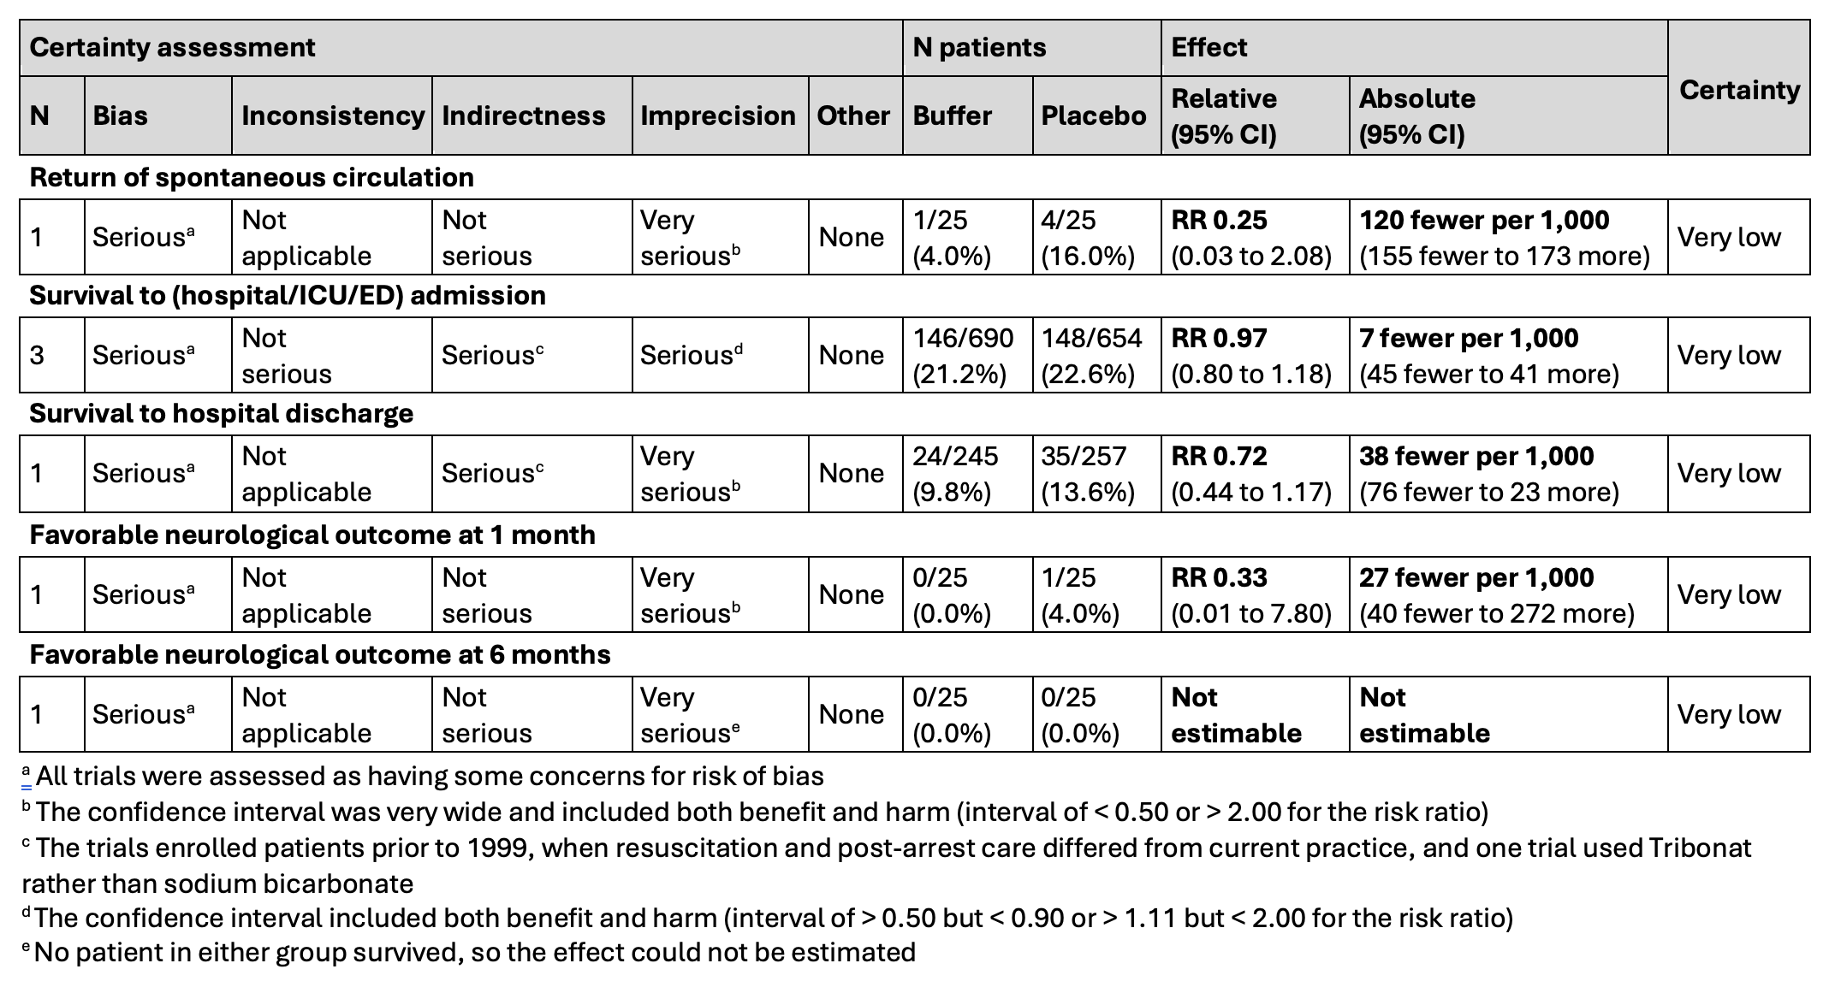

Values
Is there important uncertainty about or variability in how much people value the main outcomes?
Judgement | Research evidence | Additional considerations
○ Important uncertainty or variability  ○ Possibly important uncertainty or variability  ● Probably no important uncertainty or variability  ○ No important uncertainty or variability | Most people value survival with good neurologic outcome. Agreement is likely less for survival with poor neurologic outcome, or short-term survival without long term survival.

Balance of effects
Does the balance between desirable and undesirable effects favor the intervention or the comparison?
Judgement | Research evidence | Additional considerations
○ Favors the comparison  ○ Probably favors the comparison  ● Does not favor either the intervention or the comparison  ○ Probably favors the intervention  ○ Favors the intervention  ○ Varies  ○ Don’t know | There is no evidence of benefit on any outcome and the evidence on harm is insufficient.

Acceptability
Is the intervention acceptable to key stakeholders?
Judgement | Research evidence | Additional considerations
○ No  ○ Probably no  ○ Probably yes  ● Yes  ○ Varies  ○ Don’t know | Buffering agents are commonly administered for patients in cardiac arrest despite not being recommended in current guidelines.

Feasibility
Is the intervention feasible to implement?
Judgement | Research evidence | Additional considerations
○ No  ○ Probably no  ○ Probably yes  ● Yes  ○ Varies  ○ Don’t know | Buffering agents are commonly administered during cardiac arrest. The cost is low, particularly where these agents are already stocked for special circumstances such as hyperkalemia or sodium channel blocker poisoning.

Summary of judgements
 | Judgement
Problem | No | Probably no | Probably yes | Yes |  | Varies | Don’t know
Desirable Effects | Trivial | Small | Moderate | Large |  | Varies | Don’t know
Undesirable Effects | Large | Moderate | Small | Trivial |  | Varies | Don’t know
Certainty of evidence | Very low | Low | Moderate | High |  |  | No included studies
Values | Important uncertainty or variability | Possibly important uncertainty or variability | Probably no important uncertainty or variability | No important uncertainty or variability
Balance of effects | Favors the comparison | Probably favors the comparison | Does not favor either the intervention or the comparison | Probably favors the intervention | Favors the intervention | Varies | Don’t know
Acceptability | No | Probably no | Probably yes | Yes |  | Varies | Don’t know
Feasibility | No | Probably no | Probably yes | Yes |  | Varies | Don’t know

Type of recommendation
Strong recommendation against the intervention | Conditional recommendation against the intervention | Conditional recommendation for either the intervention or the comparison | Conditional recommendation for the intervention | Strong recommendation for the intervention
○ | ● | ○ | ○ | ○

Conclusion

Recommendation
We suggest against the routine administration of buffering agents for the treatment of out-of-hospital cardiac arrest (weak recommendation, very low certainty of evidence).

Justification
In making this recommendation we placed a higher value on not allocating resources to an ineffective intervention, which may divert rescuer time from more beneficial interventions.

Subgroup considerations
This evaluation does not address buffering agents in special circumstances, such as hyperkalemia (PICO ALS 456) and sodium channel blocker or tricyclic antidepressant poisoning (PICO ALS 429).
Prespecified subgroup analyses comparing out-of-hospital and in-hospital cardiac arrest found no clear evidence of a subgroup difference for favorable neurological survival at 1 month, survival to hospital discharge or 30 days, or return of spontaneous circulation.
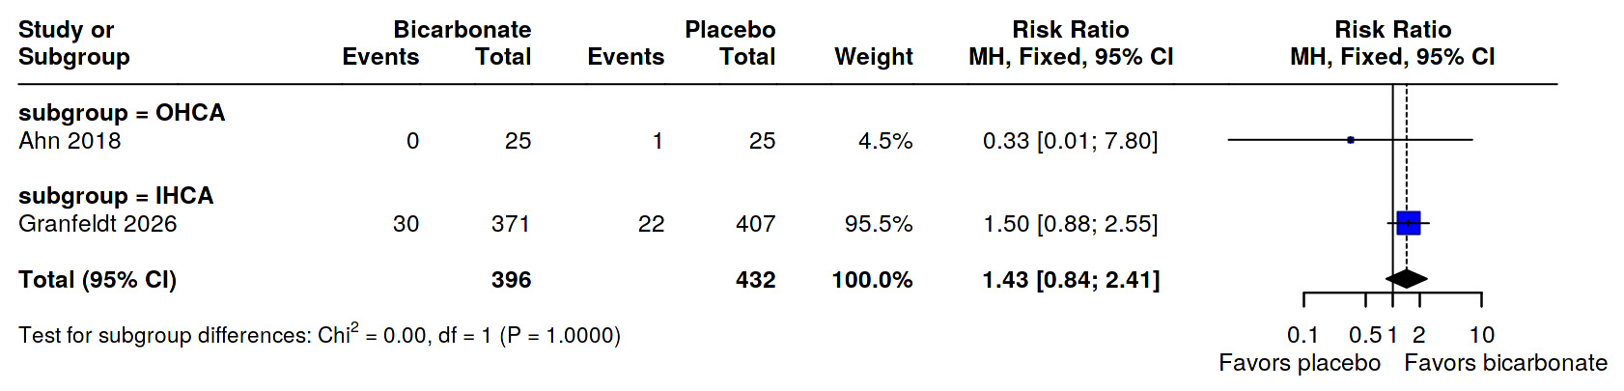
Forest plot of subgroup differences for favorable neurological survival at 1 month.
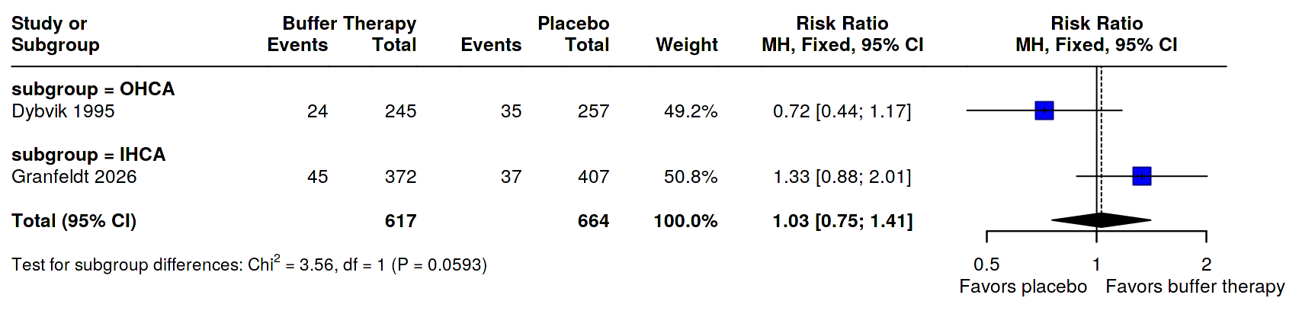Forest plot of subgroup differences for survival to hospital discharge or 30 days.
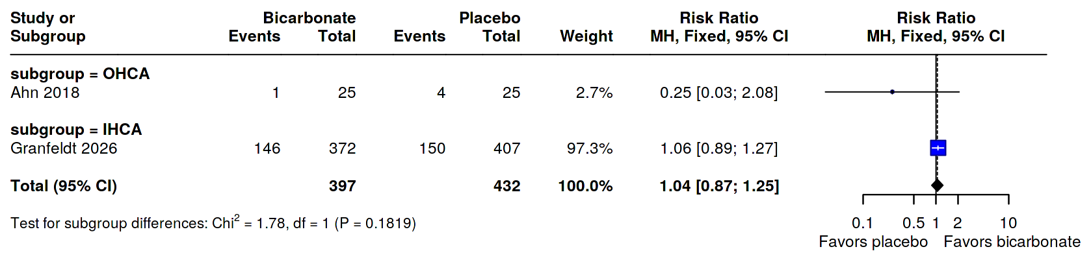
Forest plot of subgroup differences for return of spontaneous circulation.

Implementation considerations
ILCOR and international resuscitation council guidelines already recommend against routine administration of buffering agents in cardiac arrest, so no change is required.

Monitoring and evaluation

Research priorities
Adequately sized contemporary trials in out-of-hospital cardiac arrest are needed. The available trials enrolled patients before 1999 or were small, and one used Tribonat, rather than sodium bicarbonate. One trial is ongoing in patients with severe acidosis at emergency department arrival (KCT0070655). The dose and timing of administration have not been evaluated.

