Question
Carbon dioxide targets after return of spontaneous circulation (ROSC) in adults with cardiac arrest
Population: | Unresponsive adults with sustained return of spontaneous circulation (ROSC) after cardiac arrest in any setting.
Intervention: | A ventilation strategy targeting specific PaCO2 targets.
Comparison: | Treatment without specific targets or with an alternate target to the intervention.
Main outcomes: | Clinical outcome including survival/survival with a favorable neurological outcome at hospital discharge/30 days, and survival/survival with a favorable neurological outcome after hospital discharge/30 days (e.g., 90 days, 180 days, 1 year).
Setting: | Pre-hospital and ICU settings

ASSESsment

Problem
Is the problem a priority?
Judgement | Research evidence | Additional considerations
○ No  ○ Probably no  ○ Probably yes  ● Yes  ○ Varies  ○ Don't know | Cardiac arrest, both in and out-of-hospital, is relatively common and has a very high mortality. Both hypocapnia and hypercapnia have previously been thought to be associated with worse neurologic outcome in post-arrest patients. Hypocapnia can lead to cerebral vasoconstriction, which could lead to decreased perfusion in a brain already at risk for ischemic injury. Hypercapnia may increase cerebral blood flow, and thus has been posited as a possible way to mitigate hypoxic brain injury. However, the effect of hypercapnia in presence of cerebral edema due to hypoxic-ischemic brain injury is unclear.

Desirable Effects
How substantial are the desirable anticipated effects?
Judgement | Research evidence | Additional considerations
○ Trivial  ○ Small  ○ Moderate  ○ Large  ○ Varies  ● Don't know | The evidence from randomized trials and observational studies is inconsistent. Trials have failed to show any effect from different carbon dioxide targets. The largest trial to inform ventilation targets in the hospital setting found no significant differences in outcomes from targeting normocapnia (PaCO₂ of 35-45 mm Hg) and mild hypercapnia (PaCO₂ of 50-55 mm Hg). Observational studies have been evenly distributed in showing benefit, harm, or no effect associated with hypercapnia. Results for hypocapnia have also been inconsistent, although no studies have found an association with benefit.  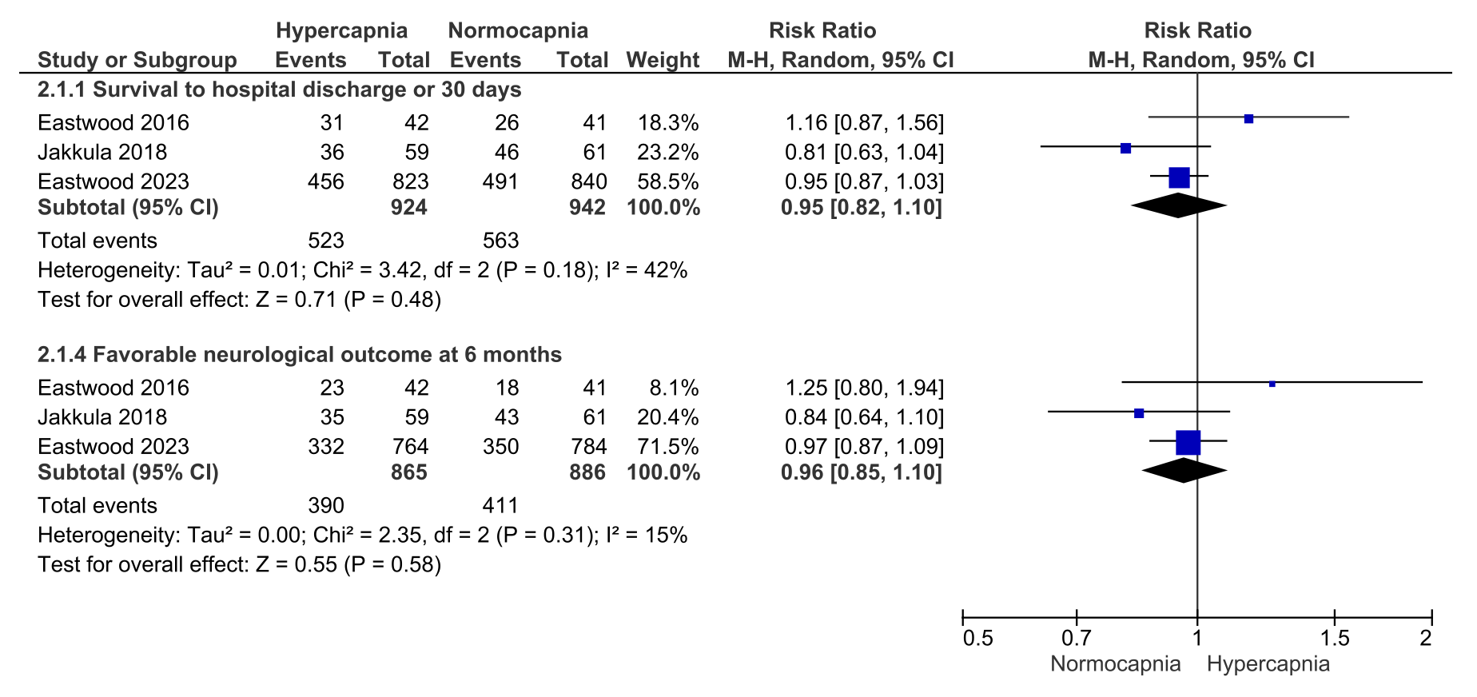

Undesirable Effects
How substantial are the undesirable anticipated effects?
Judgement | Research evidence | Additional considerations
○ Large  ○ Moderate  ○ Small  ○ Trivial  ○Varies  ● Don't know | The available evidence on the effect of hypercapnia or hypocapnia is inconsistent. Trials have failed to show any effect from different carbon dioxide targets. Observational studies have been evenly distributed in showing benefit, harm, or no effect associated with hypercapnia. Results for hypocapnia have also been inconsistent, although no studies have found an association with benefit. Whether there is a threshold at which hypocapnia and hypercapnia becomes harmful remains a knowledge gap.

Certainty of evidence
What is the overall certainty of the evidence of effects?
Judgement | Research evidence | Additional considerations
○ Very low  ○ Low  ● Moderate  ○ High  ○ No included studies | The certainty of evidence from randomized trials is moderate with the largest trial to-date including 1700 patients in the hospital setting comparing normocapnia (PaCO₂ of 35-45 mm Hg) to mild hypercapnia (PaCO₂ of 50-55 mm Hg) {Eastwood 2023 45}.  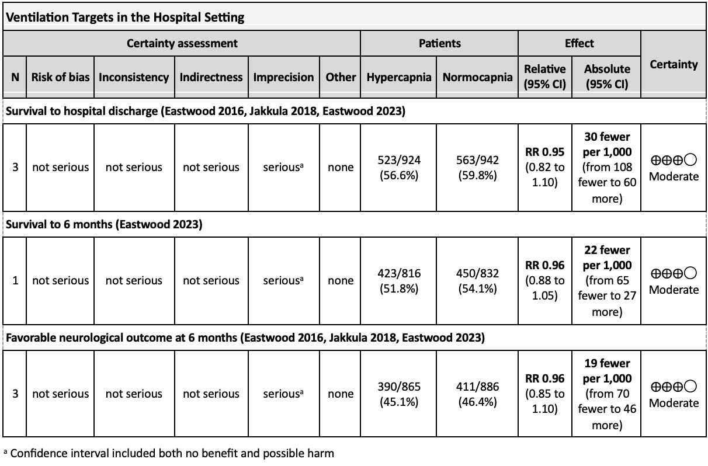

Values
Is there important uncertainty about or variability in how much people value the main outcomes?
Judgement | Research evidence | Additional considerations
○ Important uncertainty or variability  ○ Possibly important uncertainty or variability  ● Probably no important uncertainty or variability  ○ No important uncertainty or variability | Survival with favorable neurologic outcome and survival are critical outcomes.

Balance of effects
Does the balance between desirable and undesirable effects favor the intervention or the comparison?
Judgement | Research evidence | Additional considerations
○ Favors the comparison  ○Probably favors the comparison  ○ Does not favor either the intervention or the comparison  ○Probably favors the intervention  ○ Favors the intervention  ● Varies  ○ Don't know | The balance of effects favors the comparison (normocapnia) when compared to hypocapnia. The balance of effects favors neither the comparison nor the intervention when comparing normocapnia to mild to moderate hypercapnia. This balance is determined by the failure of randomized trials to show any difference between carbon dioxide targets, and observational data that is neutral on hypercapnia compared to normocapnia, and favors normocapnia over hypocapnia.

Resources required
How large are the resource requirements (costs)?
Judgement | Research evidence | Additional considerations
○ Large costs  ○ Moderate costs  ○ Negligible costs and savings  ○ Moderate savings  ○ Large savings  ○ Varies  ● Don't know | We did not identify any studies evaluating the cost of a ventilation strategy targeting one carbon dioxide range over another, but a significant cost seems unlikely, except in settings where the costs blood gas analysis are high for the available resources.

Certainty of evidence of required resources
What is the certainty of the evidence of resource requirements (costs)?
Judgement | Research evidence | Additional considerations
○ Very low  ○ Low  ○ Moderate  ○ High  ● No included studies | We did not identify any studies specifically comparing resources including costs between the two interventions.

Cost effectiveness
Does the cost-effectiveness of the intervention favor the intervention or the comparison?
Judgement | Research evidence | Additional considerations
○ Favors the comparison  ○ Probably favors the comparison  ○ Does not favor either the intervention or the comparison  ○ Probably favors the intervention  ○ Favors the intervention  ○ Varies  ● No included studies | We did not identify any studies addressing cost-effectiveness.

Equity
What would be the impact on health equity?
Judgement | Research evidence | Additional considerations
○ Reduced  ○ Probably reduced  ○ Probably no impact  ○ Probably increased  ○ Increased  ○ Varies  ● Don't know | Targeting a specific carbon dioxide value may be difficult in settings where blood gas analysis is not available. However, as measuring carbon dioxide values is not a change from previous recommendations, we do not think that recommending a specific target will change existing equity or inequity.

Acceptability
Is the intervention acceptable to key stakeholders?
Judgement | Research evidence | Additional considerations
○ No  ○ Probably no  ● Probably yes  ○ Yes  ○ Varies  ○ Don't know | We have not identified any research that assessed acceptability, but these treatment recommendations do not include any substantial changes compared to 2020.

Feasibility
Is the intervention feasible to implement?
Judgement | Research evidence | Additional considerations
○ No  ○ Probably no  ● Probably yes  ○ Yes  ○ Varies  ○ Don't know | Feasibility was not specifically addressed by this review but should be feasible in most settings given that this is not a significant change in recommendation.

Summary of judgements
 | Judgement
Problem | No | Probably no | Probably yes | Yes |  | Varies | Don't know
Desirable Effects | Trivial | Small | Moderate | Large |  | Varies | Don't know
Undesirable Effects | Large | Moderate | Small | Trivial |  | Varies | Don't know
Certainty of evidence | Very low | Low | Moderate | High |  |  | No included studies
Values | Important uncertainty or variability | Possibly important uncertainty or variability | Probably no important uncertainty or variability | No important uncertainty or variability
Balance of effects | Favors the comparison | Probably favors the comparison | Does not favor either the intervention or the comparison | Probably favors the intervention | Favors the intervention | Varies | Don't know
Resources required | Large costs | Moderate costs | Negligible costs and savings | Moderate savings | Large savings | Varies | Don't know
Certainty of evidence of required resources | Very low | Low | Moderate | High |  |  | No included studies
Cost effectiveness | Favors the comparison | Probably favors the comparison | Does not favor either the intervention or the comparison | Probably favors the intervention | Favors the intervention | Varies | No included studies
Equity | Reduced | Probably reduced | Probably no impact | Probably increased | Increased | Varies | Don't know
Acceptability | No | Probably no | Probably yes | Yes |  | Varies | Don't know
Feasibility | No | Probably no | Probably yes | Yes |  | Varies | Don't know

Type of recommendation
Strong recommendation against the intervention | Conditional recommendation against the intervention | Conditional recommendation for either the intervention or the comparison | Conditional recommendation for the intervention | Strong recommendation for the intervention
○ | ● | ● | ○ | ○

Conclusions

Recommendations
We suggest targeting normocapnia (a partial pressure of carbon dioxide of 35-45 mm Hg or approximately 4.7-6.0 kPa) in adults with ROSC after cardiac arrest (weak recommendation, moderate certainty evidence).

Justification
The evidence from RCTs and observational studies is inconsistent. RCTs have failed to show any effect from different CO2 targets. The largest RCT to inform ventilation targets in the hospital setting found no significant differences in outcomes from targeting normocapnia (PaCO2 of 35-45 mm Hg) and mild hypercapnia (PaCO2 of 50-55 mm Hg) {Eastwood 2023 45}. Observational studies have been evenly distributed in showing benefit, harm, or no effect associated with hypercapnia. Results for hypocapnia have also been inconsistent, although no studies have found an association with benefit.

Considering the lack of evidence for benefit or harm from targeting CO2 levels above or below the normal range, the task forces deemed it reasonable to target normocapnia, generally defined as a PaCO2 of 35-45 mm Hg in both RCTs and observational studies. Notably, the task force is aware of unpublished data from one RCT {Bernard 2022 1818} and observational studies not included in this review {Moon 2007 219; Mueller 2022 120; Kim 2019 1; Abrahamowicz 2022 3} suggesting that ETCO2 levels may not accurately reflect PaCO2 levels, which may be an important consideration in the prehospital setting. As with all critically ill patients, there may be specific scenarios in which CO2 levels may need to be higher or lower than normal to compensate for other illnesses (e.g., severe lung injury or metabolic acidosis).

The task forces discussed the possible complication of acidemia from hypercapnia. The presence or absence of metabolic acidosis requires consideration when choosing a ventilation strategy and PaCO2 target, and metabolic acidosis is common in post-arrest patients. Additionally, opinions vary on whether arterial blood gas analysis in patients receiving targeted temperature management should be adjusted for temperature. Approaches to blood gas interpretation regarding temperature varied across RCTs and observational studies. These variations in methodology and in definitions of target ranges prohibit the task forces from being able to recommend specific numbers or a specific method for blood gas analysis for systems implementing these recommendations.

Subgroup considerations
The task forces discussed whether cardiac arrest patients with baseline chronic lung disease and chronic CO2 retention might respond differently to different CO2 targets, however, no evidence addressing this subgroup was found. The task forces agreed that it would be reasonable to adjust PaCO2 targets in patients with known chronic CO2 retention (expert opinion).

Implementation considerations
These recommendations have not changed significantly compared to 2020, so the task force did not think implementation would be a challenge.

Monitoring and evaluation

Research priorities
The evidence regarding the effect of different ventilation targets in post-arrest patients remains limited. The following knowledge gaps have been identified:
1. Whether there is a threshold at which hypocapnia and hypercapnia becomes harmful
2. The accurate correlation of ETCO₂ with PaCO₂ levels
3. The effects of manipulating PaCO₂ on cerebral blood flow in post-cardiac arrest
4. How PaCO₂ targets should be adjusted in those with chronic CO₂ retention
5. Whether arterial blood gas analysis should be adjusted to 37°C or to a patient’s current temperature

