Question
Oxygenation strategy after return of spontaneous circulation (ROSC) in adults with cardiac arrest
Population: | Unresponsive adults with sustained return of spontaneous circulation (ROSC) after cardiac arrest in any setting.
Intervention: | A ventilation strategy targeting specific SpO2 and PaO2 targets.
Comparison: | Treatment without specific targets or with an alternate target to the intervention.
Main outcomes: | Clinical outcome including survival/survival with a favorable neurological outcome at hospital discharge/30 days, and survival/survival with a favorable neurological outcome after hospital discharge/30 days (e.g., 90 days, 180 days, 1 year).
Setting: | Prehospital and ICU settings

ASSESsment

Problem
Is the problem a priority?
Judgement | Research evidence | Additional considerations
○ No  ○ Probably no  ○ Probably yes  ● Yes  ○ Varies  ○ Don't know | Cardiac arrest, both in and out-of-hospital, is relatively common and has a very high mortality. Previously, both hypoxemia and hyperoxia have been reported to be associated with worse outcome in patients who are post-cardiac arrest. Hypoxemia may worsen ischemic brain injury and injury to other organs, while hyperoxia may lead to increased oxidative stress and organ damage after reperfusion. New randomized trials have been published since this topic was last updated in 2020.

Desirable Effects
How substantial are the desirable anticipated effects?
Judgement | Research evidence | Additional considerations
○ Trivial  ○ Small  ○ Moderate  ○ Large  ○ Varies  ● Don't know | The evidence on the effect of different oxygen target on survival and neurologic outcome is mixed, with inconsistencies across observational studies and randomized trials in both methodology and results. Observational studies, identified in the previous review from 2020, were all at serious or critical risk of bias, reporting a mix of positive and negative results. Trials conducted in the hospital setting have generally been more suggestive of benefit from normoxia than trials conducted in the prehospital setting, although many individual trials have been limited by a small sample size. The pooled results and the most comprehensive randomized trials in the prehospital {Bernard 2022 1818} and in-hospital {Schmidt 2022 1467} settings, which compared an oxygen saturation of 90-94% to 98-100% and a PaO₂ of 9-10 kPa to 13-15 kPa respectively, and found no significant evidence favoring either the higher or lower oxygen targets.  Meta-analyses for oxygen targets in the prehospital setting  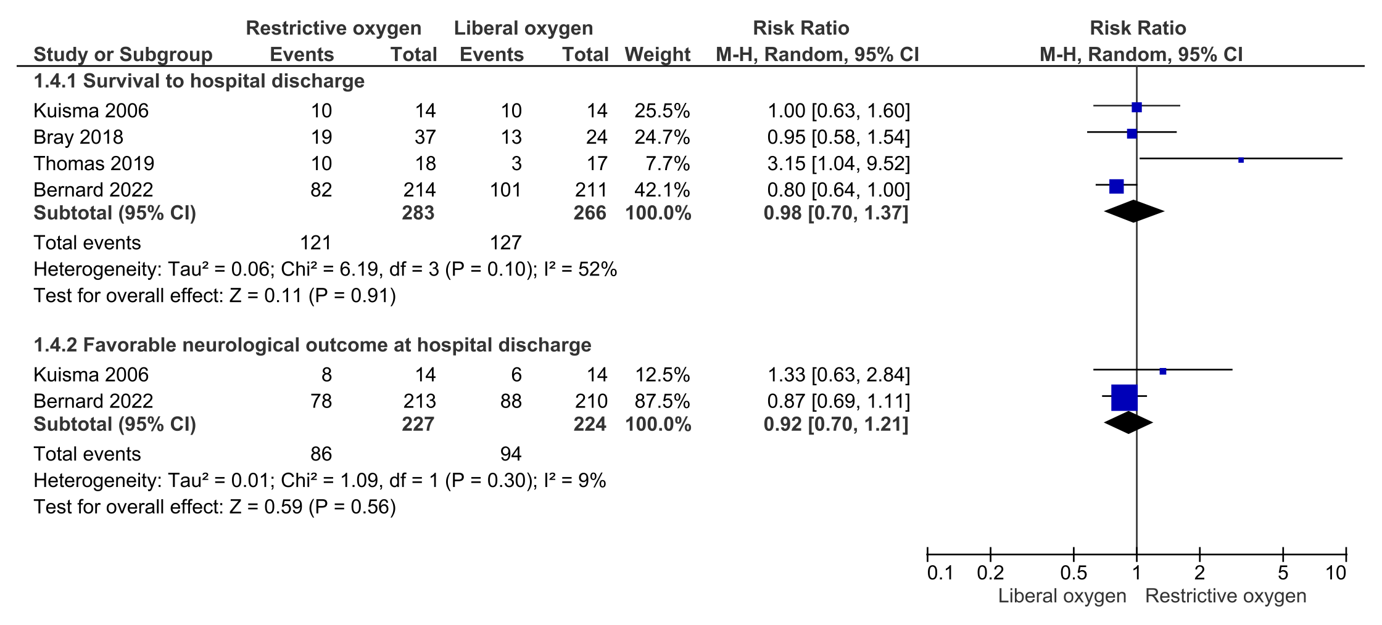  Meta-analyses for oxygen targets in the ICU setting  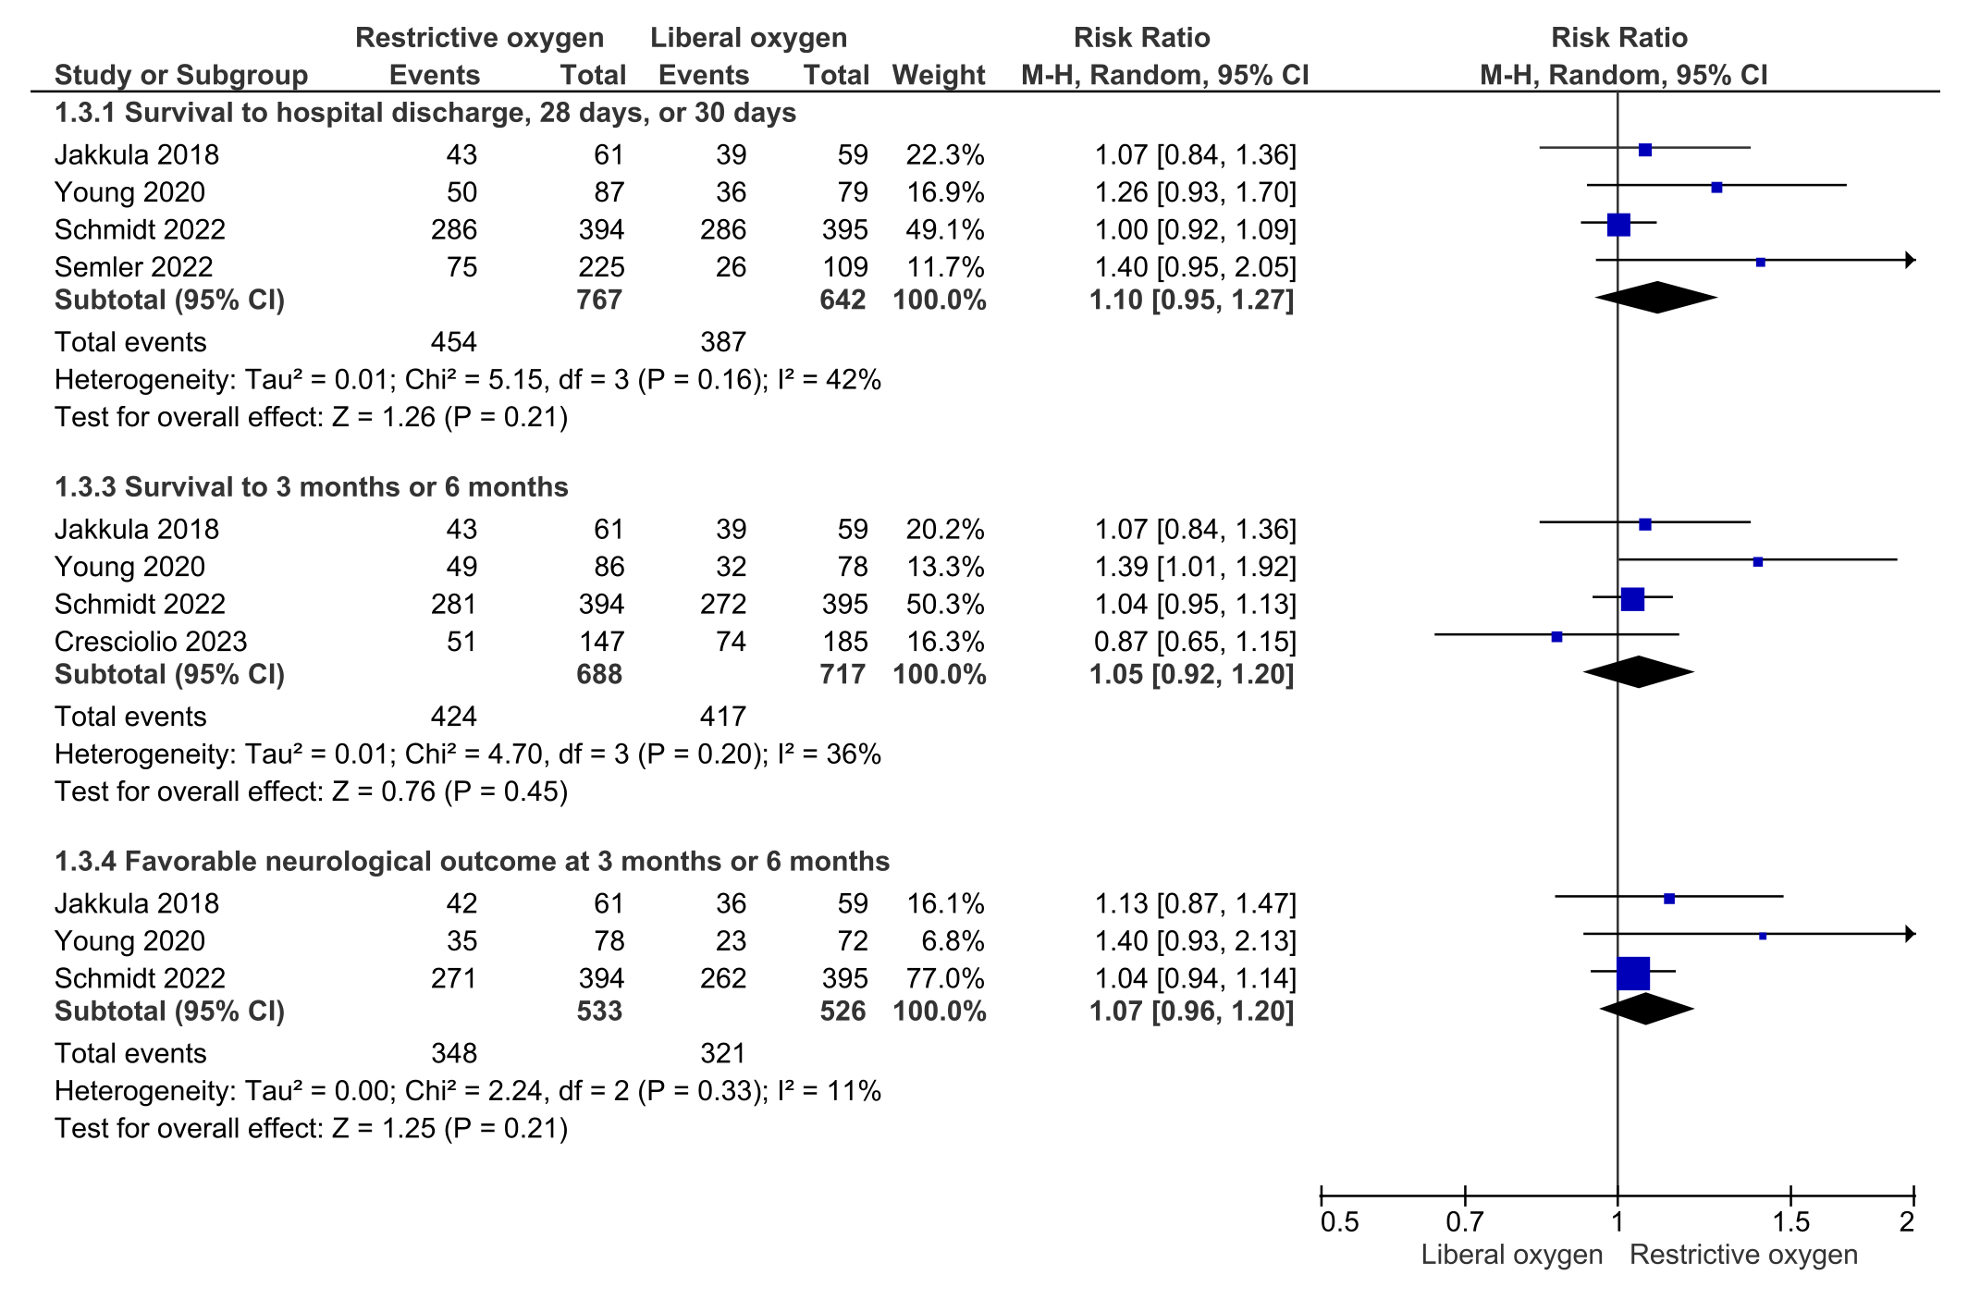

Undesirable Effects
How substantial are the undesirable anticipated effects?
Judgement | Research evidence | Additional considerations
○ Large  ○ Moderate  ○ Small  ○ Trivial  ● Varies  ○ Don't know | Although the evidence is of low certainty, it is likely that the undesirable effects of hypoxia are significant. Furthermore, the largest randomized trial to inform oxygenation targets in the prehospital setting (comparing oxygen saturation targets of 90-94% to 98-100%) suggests that early titration to a lower oxygen target is harmful {Bernard 2022 1818}.  The undesirable effects of hyperoxia are uncertain due to mixed results showing either harm (in observational studies included in the 2020 systematic review) or no benefit (in randomized trials).

Certainty of evidence
What is the overall certainty of the evidence of effects?
Judgement | Research evidence | Additional considerations
○ Very low  ○ Low  ● Moderate  ○ High  ○ No included studies | The certainty of evidence varies across the included studies from very low to moderate.  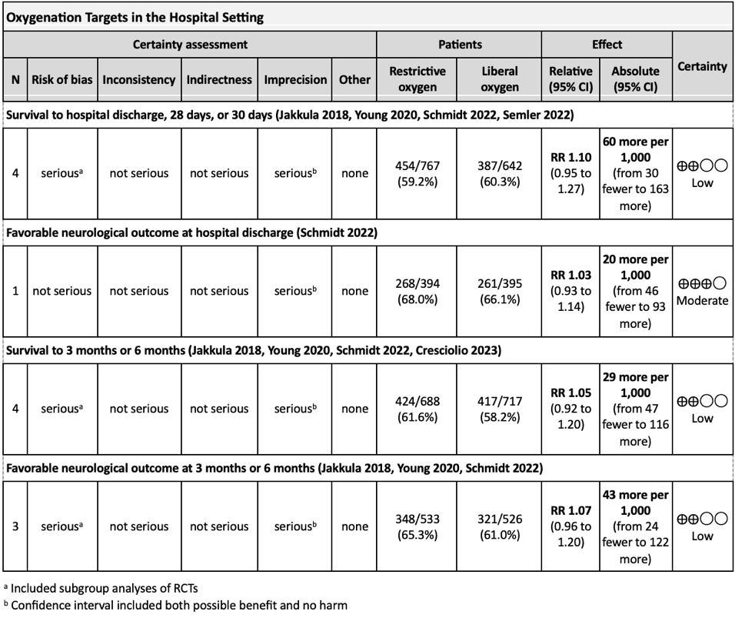  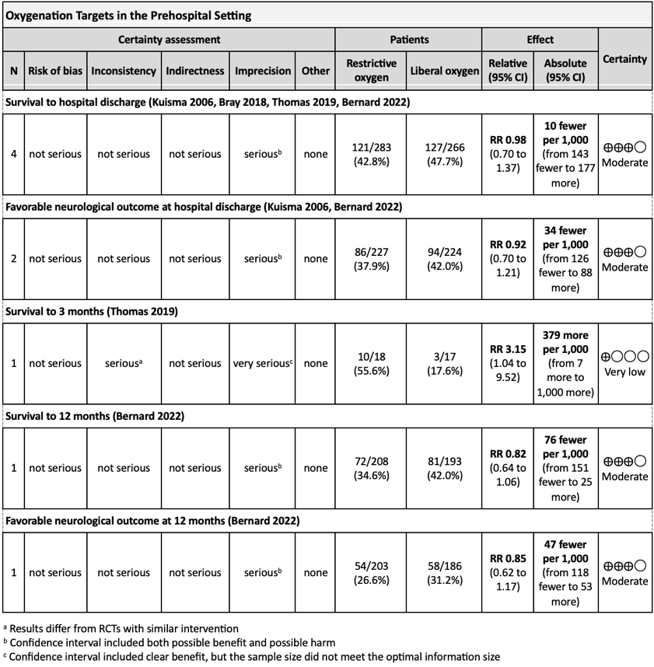

Values
Is there important uncertainty about or variability in how much people value the main outcomes?
Judgement | Research evidence | Additional considerations
○ Important uncertainty or variability  ○ Possibly important uncertainty or variability  ● Probably no important uncertainty or variability  ○ No important uncertainty or variability | Survival with favorable neurologic outcome and survival are generally accepted as critical outcomes. {Haywood 2018 e783}

Balance of effects
Does the balance between desirable and undesirable effects favor the intervention or the comparison?
Judgement | Research evidence | Additional considerations
○ Favors the comparison  ○Probably favors the comparison  ○ Does not favor either the intervention or the comparison  ●Probably favors the intervention  ○ Favors the intervention  ○ Varies  ○ Don't know | For hyperoxia, studies generally show either association with harm or no association, but do not generally show association with benefit. The balance of evidence therefore slightly favors a benefit from normoxia in comparison with hyperoxia.  For hypoxemia, limited evidence favors avoiding hypoxemia, with a benefit from normoxia. Moreover, some of the randomized trials conducted in the prehospital setting reported more desaturation of arterial blood in the lower oxygen target groups, and the largest trial in the prehospital setting to inform oxygenation targets (comparing oxygen saturation targets of 90-94% to 98-100%) suggests that early titration to a lower oxygen target is harmful {Bernard 2022 1818}.

Resources required
How large are the resource requirements (costs)?
Judgement | Research evidence | Additional considerations
○ Large costs  ○ Moderate costs  ○ Negligible costs and savings  ○ Moderate savings  ○ Large savings  ○ Varies  ● Don't know | We did not identify any studies evaluating the cost of an oxygen strategy targeting a specific oxygen level. However, as it is the current standard of care to measure an oxygen saturation continuously in post-arrest, critically-ill patients, and since a titrated oxygen approach would lead to the same or decreased oxygen use, it is likely that an intervention to avoid hyperoxia would not incur significant cost. | In lower resource settings where pulse oximetry and arterial blood gas analysis are not routinely available, titration of oxygen may be less feasible.

Certainty of evidence of required resources
What is the certainty of the evidence of resource requirements (costs)?
Judgement | Research evidence | Additional considerations
○ Very low  ○ Low  ○ Moderate  ○ High  ● No included studies | We did not identify any studies specifically comparing resources including costs between the two interventions.

Cost effectiveness
Does the cost-effectiveness of the intervention favor the intervention or the comparison?
Judgement | Research evidence | Additional considerations
○ Favors the comparison  ○ Probably favors the comparison  ○ Does not favor either the intervention or the comparison  ○ Probably favors the intervention  ○ Favors the intervention  ○ Varies  ● No included studies | We did not identify any studies addressing cost-effectiveness.

Equity
What would be the impact on health equity?
Judgement | Research evidence | Additional considerations
○ Reduced  ○ Probably reduced  ○ Probably no impact  ○ Probably increased  ○ Increased  ○ Varies  ● Don't know | We did not identify any studies addressing the effect of titration of oxygen to specific targets on health equity in post-arrest patients. In resource-poor settings where ICU equipment and oxygen may be of limited supply, titrating to the minimum amount of oxygen needed to maintain a saturation in the normal range could increase equity by reserving oxygen for other patients. {Sutherland 2019 1138}

Acceptability
Is the intervention acceptable to key stakeholders?
Judgement | Research evidence | Additional considerations
○ No  ○ Probably no  ● Probably yes  ○ Yes  ○ Varies  ○ Don't know | We have not identified any research that assessed acceptability, but these treatment recommendations do not include any substantial changes compared to 2020. | Although we did not identify any studies addressing acceptability, it is common practice to decrease FiO₂ for other critically ill patients once reliable monitoring of oxygenation is available.

Feasibility
Is the intervention feasible to implement?
Judgement | Research evidence | Additional considerations
○ No  ○ Probably no  ● Probably yes  ○ Yes  ○ Varies  ○ Don't know | Feasibility was not specifically addressed by this review. However, avoiding hyperoxia should be feasible in most ICU settings where patients are continually monitored. Decreasing FiO₂ in the pre-hospital setting or in the immediate post-arrest period may be less feasible as measurement of arterial oxygen may be hard to obtain reliably and could potentially lead to desaturation. Some pre-hospital systems utilize transport ventilators that do not have the capacity to adjust the fraction of inspired oxygen, which may also limit feasibility in the pre-hospital setting. There may be significant limitations to feasibility for many aspects of post-arrest care in resource-poor settings, but this is not specific to oxygen titration.

Summary of judgements
 | Judgement
Problem | No | Probably no | Probably yes | Yes |  | Varies | Don't know
Desirable Effects | Trivial | Small | Moderate | Large |  | Varies | Don't know
Undesirable Effects | Large | Moderate | Small | Trivial |  | Varies | Don't know
Certainty of evidence | Very low | Low | Moderate | High |  |  | No included studies
Values | Important uncertainty or variability | Possibly important uncertainty or variability | Probably no important uncertainty or variability | No important uncertainty or variability
Balance of effects | Favors the comparison | Probably favors the comparison | Does not favor either the intervention or the comparison | Probably favors the intervention | Favors the intervention | Varies | Don't know
Resources required | Large costs | Moderate costs | Negligible costs and savings | Moderate savings | Large savings | Varies | Don't know
Certainty of evidence of required resources | Very low | Low | Moderate | High |  |  | No included studies
Cost effectiveness | Favors the comparison | Probably favors the comparison | Does not favor either the intervention or the comparison | Probably favors the intervention | Favors the intervention | Varies | No included studies
Equity | Reduced | Probably reduced | Probably no impact | Probably increased | Increased | Varies | Don't know
Acceptability | No | Probably no | Probably yes | Yes |  | Varies | Don't know
Feasibility | No | Probably no | Probably yes | Yes |  | Varies | Don't know

Type of recommendation
Strong recommendation against the intervention | Conditional recommendation against the intervention | Conditional recommendation for either the intervention or the comparison | Conditional recommendation for the intervention | Strong recommendation for the intervention
○ | ○ ● | ○ | • | ○

Conclusions

Recommendations
Oxygen targets

We recommend the use of 100% inspired oxygen until the arterial oxygen saturation, or the partial pressure of arterial oxygen can be measured reliably in adults with ROSC after cardiac arrest in the pre-hospital setting (strong recommendation, moderate certainty evidence) and in-hospital setting (strong recommendation, low certainty evidence).

We recommend avoiding hypoxemia in adults with ROSC after cardiac arrest in any setting (strong recommendation, very low certainty evidence).

We suggest avoiding hyperoxemia in adults with ROSC after cardiac arrest in any setting (weak recommendation, low certainty evidence).

Following reliable measurement of arterial oxygen levels, we suggest targeting an oxygen saturation of 94-98% or a partial pressure of arterial oxygen of 75-100 mm Hg (approximately 10-13 kPa) in adults with ROSC after cardiac arrest in any setting (good practice statement).

When relying on pulse oximetry, health care professionals should be aware of the increased risk of inaccuracy that may conceal hypoxemia in patients with darker skin pigmentation (good practice statement).

Justification
The task forces felt that oxygen titration should not be attempted until oxygen levels (arterial oxygen saturation with a pulse oximeter or partial pressure of oxygen in arterial blood) can be measured reliably. This is most likely to be an important consideration in the prehospital setting where arterial blood gas analysis is rarely available and peripheral oxygen saturation may be difficult to obtain consistently. Some of the RCTs conducted in the prehospital setting reported more desaturation of arterial blood in the lower oxygen target groups, and the largest RCT to inform oxygenation targets (comparing oxygen saturation targets of 90-94% to 98-100%) suggests that early titration to a lower oxygen target is harmful {Bernard 2022 1818}. Most patients in the standard care arm of that RCT received 100% oxygen prior to hospital arrival, rather than titrated levels, due to the introduction of air-mix mechanical ventilators. Hence, the task forces deemed it acceptable to temporarily target a higher oxygen range to mitigate the risk of hypoxemia. The task forces discussed whether the evidence favored avoiding any titration of oxygen in the prehospital setting since most patients in the EXACT trial {Bernard 2022 1818} received 100% oxygen without titration. However, most thought that once reliable measurement of oxygenation was available, the evidence only supported not titrating to a lower target range of 90-94%. The separate recommendations for different settings, with a stronger recommendation for the prehospital setting, were influenced by the evidence of harm from that same RCT as well as the differing certainty of evidence in the prehospital and ICU studies.

In making the recommendation to avoid hypoxemia, the task forces acknowledges that the evidence is of very low certainty from observational studies. The task forces concluded that the physiologic basis for hypoxia being harmful justifies its avoidance, and detection of hypoxemia may be the best surrogate for true hypoxia.

The suggestion to avoid hyperoxemia is based on very low to moderate certainty evidence that showed either harm (in observational studies included in the 2020 systematic review) or no benefit (in RCTs) from hyperoxemia. It is important to consider that the RCTs generally compared a conservative oxygen strategy with a liberal oxygen strategy. Observational studies, which compared oxygen levels rather than strategies, generally defined the hyperoxemia group as those with PaO₂ > 300 mm Hg, a level above what many would consider usual care.

The variability in oxygenation targets across RCTs and observational studies makes it difficult to identify an evidence-based optimal range. However, the task forces recognized the need for more precise guidance than what has previously been provided. The most comprehensive RCTs in the prehospital {Bernard 2022 1818} and hospital {Schmidt 2022 1467} settings, which compared an oxygen saturation of 90-94% to 98-100% and a PaO₂ of 9-10 kPa to 13-15 kPa, don’t identify a specific optimal arterial oxygen saturation or partial pressure of oxygen but support normoxemia being safe. Given the absence of conclusive evidence for specific oxygen levels outside the normoxemia range, the task force agreed that targeting an oxygen saturation of 94-98% or a PaO2 target of 75-100 mm Hg (10-13 kPa) is reasonable.

While studies evaluating the accuracy of pulse oximetry in people with different degrees of skin pigmentation were not part of this systematic review, the systematic review team and task forces are aware of and considered several such studies that have found a slightly higher risk of occult hypoxemia (pulse oximetry reading of greater than 90% saturation while arterial oxygen saturation by blood gas is < 88%) in people with darker skin. {Sjoding 2020 2477; Won 2021 e2131674; Jamali 2022 1951} While none of these studies were done in cardiac arrest patients, the task forces felt that this issue was important to make medical professionals treating cardiac arrest patients aware of, as this knowledge could inform decision making about whether to titrate supplemental oxygen. The task forces provided a good practice statement to highlight this issue, while acknowledging that this evidence was not formally evaluated as part of this systematic review.

Subgroup considerations
The studies available have included both cardiac arrests in the in-hospital and out-of-hospital seting, and generally have not analyzed patients separately. No evidence suggesting a differential effect was found.

Implementation considerations
These recommendations have not changed significantly compared to 2020, so the task force did not think implementation would be a challenge.

Monitoring and evaluation

Research priorities
The evidence regarding the effect of targeting different levels of oxygenation in post-arrest patients remains limited. The following knowledge gaps have been identified:
1. The optimal oxygen target for post-cardiac arrest patients
2. Whether there is a threshold at which hypoxemia and hyperoxemia becomes harmful
3. The optimal duration for specific oxygen strategies

