BLS 2721 CPR in Microgravity Environments (SyR)
Table: Current CPR techniques that have been evaluated in the microgravity setting
Technique | CMRS | Figure | Description
Standard Side Straddle | Required | 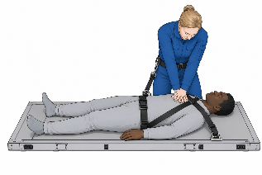 | The rescuer positions themselves beside the patient, who is secured on the crew medical restraint system, and performs chest compressions from the side
Waist Straddling | Required | 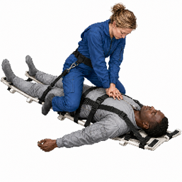 | The rescuer straddles the patient’s waist while the patient is secured on the crew medical restraint system
Handstand | Required | 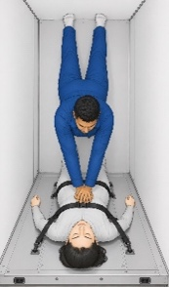 | The rescuer braces their feet against one cabin wall while the patient’s back is supported against the opposite wall to perform chest compressions
Reverse Bear Hug | Not required | 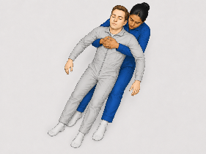 | The rescuer positions behind the patient and applies chest compressions by wrapping both arms around the patient’s chest
Evetts-Russomano | Not required | 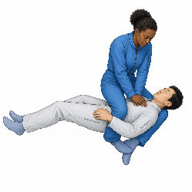 | The rescuer positions him/herself on top of the patient, crossing their legs over the patient’s shoulder and back. The force exerted by the practitioner’s crossed legs counters the chest compressions applied against the sternum
Cologne | Not required | 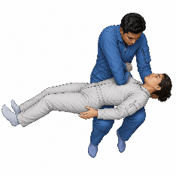 | The rescuer stabilizes the patient on their thighs and deliver chest compressions using one elbow
Schmitz-Hinkelbein | Not required | 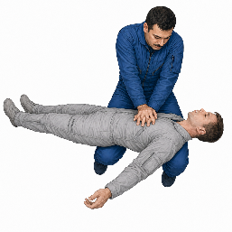 | The rescuer stabilizes the patient on their thighs and deliver chest compressions using both arms
CMRS: Crew Medical Restraint System, CPR: Cardiopulmonary resuscitation. ChatGPT 5.6 was used to help create illustrations demonstrating CPR techniques in a microgravity environment.

