Question
Should passive ventilation vs. standard CPR be used for patients in cardiac arrest?
Population: | Adults and children in cardiac arrest
Intervention: | Any passive ventilation technique (eg positioning the body, opening the airway, passive oxygen administration, Boussignac tube, constant flow insufflation of oxygen) in addition to chest compression
Comparison: | Standard CPR
Main outcomes: | ROSC, survival to hospital admission, survival to ICU discharge, neurologically intact survival to hospital discharge
Setting: | in-hospital and out-of-hospital setting
Perspective: | Patient
Background: | Administration of adequate ventilation is essential to successful resuscitation after cardiac arrest. Positive-pressure ventilation, through bag-valve-mask or an advanced airway, has been the fundamental approach during CPR. Passive ventilation during CPR may provide a viable out-of-hospital cardiac arrest treatment alternative. During chest compression-only CPR in the out of hospital setting, some EMS systems have chosen to provide passive ventilation in the form of an airway maneuver and/or device combined with an oxygen-delivery mask.
Conflict of interests:

Assessment

Problem
Is the problem a priority?
Judgement | Research evidence | Additional considerations
○ No  ○ Probably no  ○ Probably yes  ● Yes  ○ Varies  ○ Don't know | Mortality after cardiac arrest remains high, and there is broad consensus that new treatments and strategies are needed. | Passive ventilation may represent a new alternative positive-pressure ventilation. In addition, this approach may:  - Shorten interruptions in chest compression for advance airway management  - Overcome the potential detrimental effects of positive-pressure ventilation: rising in intrathoracic pressure; reduced venous return to the heart; reduced coronary perfusion pressure; increased pulmonary vascular resistance.

Desirable Effects
How substantial are the desirable anticipated effects?
Judgement | Research evidence | Additional considerations
● Trivial  ○ Small  ○ Moderate  ○ Large  ○ Varies  ○ Don't know | 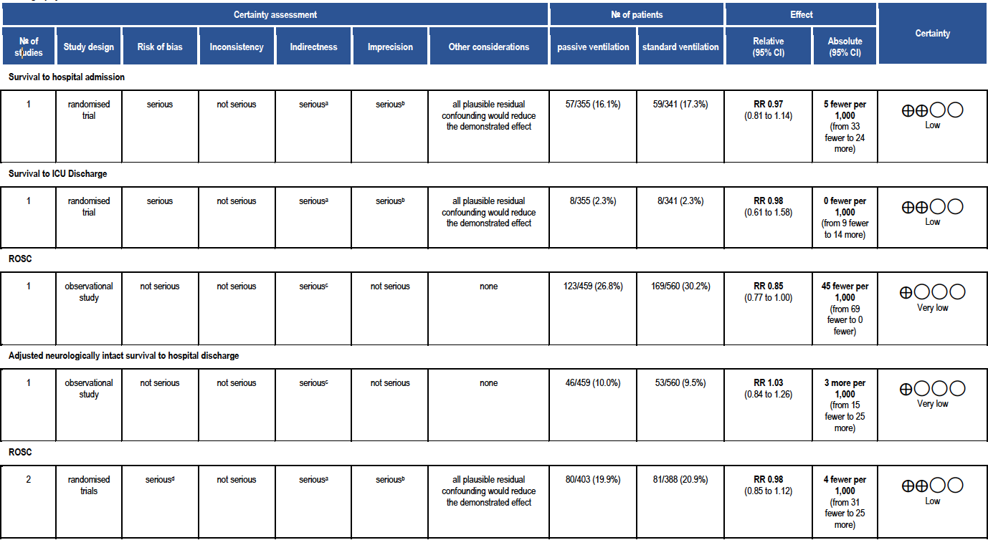  Two RCTs compared intermittent positive-pressure ventilation via an endotracheal tube with continuous insufflation of oxygen through a modified endotracheal tube. The third study compared placement of an oropharyngeal airway and administration of oxygen by nonrebreather mask or by bag-mask ventilation during a bundle of care involving 200 continuous chest compressions and delayed intubation.  Additional data from a pilot RCT reported no statistical difference in ROSC when chest compression-induced ventilation with continuous positive airway pressure in 9 patients was compared to standard volume-controlled ventilation in 11 patients (22% vs. 9%). | The overall quality of evidence was rated as very low primarily due to a critical risk of bias. The individual studies were all at a critical risk of bias due to confounding and indirectness.  Because of a high degree of heterogeneity, the meta-analyses included only 2 RCTs, in which passive ventilation through constant flow insufflation of oxygen with the aid of a modified endotracheal tube was compared to mechanical ventilation.  Additional data from the largest RCT included in the meta-analysis (Bertand 2006) showed that the percentage of patients with measurable SpO2 and with values above 70% were both significantly greater in the constant flow insufflation of oxygen group compared to standard CPR.  The Boussignac tube used in these studies is known to generate a constant endotracheal pressure of approx. 10 cmH2O. In addition, the active compression decompression device, when available, was used to perform CPR. The above adjuncts may have played a role in the generation and in the magnitude of passive ventilation by chest compression.  The observational study presents critical problems related to indirectness. Indeed, different CPR protocols were compared, characterized not only by different ventilation strategies but also by different rhythm check timings, compression/ventilation ratios, and compression intervals between shocks.  No studies were found describing this approach in the lay rescuer setting.

Undesirable Effects
How substantial are the undesirable anticipated effects?
Judgement | Research evidence | Additional considerations
○ Large  ○ Moderate  ○ Small  ● Trivial  ○ Varies  ○ Don't know | There is a lack of evidence for or against undesirable effects of passive ventilation. | No studies investigated this approach in the lay rescuer setting.

Certainty of evidence
What is the overall certainty of the evidence of effects?
Judgement | Research evidence | Additional considerations
● Very low  ○ Low  ○ Moderate  ○ High  ○ No included studies | The overall certainty of evidence is VERY LOW. All the included studies had a very high risk of bias.  The 2 RCTs included in the meta-analyses, employed CPR protocols including the use of the Boussignac tube, known to generate a constant endotracheal pressure of approx. 10 cmH2O, and the active compression decompression device, when available.  The observational study compared different CPR protocols, characterized not only by different ventilation strategies but also by different rhythm check timings, compression/ventilation ratios, and compression intervals between shocks.  No studies were found describing this approach in the lay rescuer setting.

Values
Is there important uncertainty about or variability in how much people value the main outcomes?
Judgement | Research evidence | Additional considerations
○ Important uncertainty or variability  ○ Possibly important uncertainty or variability  ○ Probably no important uncertainty or variability  ● No important uncertainty or variability | With reference to the guidance provided by the COSCA initiative ("Core Outcome Set for Cardiac Arrest" - a partnership between patients, their partners, clinicians, research scientists, and the International Liaison Committee on Resuscitation, sought to develop a consensus core outcome set for cardiac arrest for effectiveness trials), there is no important uncertainty about how much people would value favourable survival or survival as an outcome. | Haywood K, Whitehead L, Nadkarni VM, Achana F, Beesems S, Böttiger BW, Brooks A, Castrén M, Ong MEH, Hazinski MF, Koster RW, Lilja G, Long J, Monsieurs KG, Morley PT, Morrison L, Nichol G, Oriolo V, Saposnik G, Smyth M, Spearpoint K, Williams B, Perkins GD; COSCA Collaborators. COSCA (Core Outcome Set for Cardiac Arrest) in Adults: An Advisory Statement From the International Liaison Committee on Resuscitation. Resuscitation. 2018 Jun;127:147-163. doi: 10.1016/j.resuscitation.2018.03.022.

Balance of effects
Does the balance between desirable and undesirable effects favor the intervention or the comparison?
Judgement | Research evidence | Additional considerations
○ Favors the comparison  ○ Probably favors the comparison  ● Does not favor either the intervention or the comparison  ○ Probably favors the intervention  ○ Favors the intervention  ○ Varies  ○ Don't know | No differences in both critical and important outcomes have been observed. Similarly, no undesirable effects have been reported. Nevertheless, due to the above reported critical risk of bias, both desirable and undesirable effects of the intervention remain very uncertain.

Resources required
How large are the resource requirements (costs)?
Judgement | Research evidence | Additional considerations
○ Large costs  ○ Moderate costs  ○ Negligible costs and savings  ○ Moderate savings  ○ Large savings  ○ Varies  ● Don't know | The cost or need for resources to implement the intervention is uncertain. Introducing the passive ventilation approach in a resuscitation system will require resources for training and education. If passive ventilation would be delivered through the Boussignac tube and/or with the use of an active compression-decompression device, the costs then could be higher compared to current standard.

Certainty of evidence of required resources
What is the certainty of the evidence of resource requirements (costs)?
Judgement | Research evidence | Additional considerations
○ Very low  ○ Low  ○ Moderate  ○ High  ● No included studies | No evidence identified.

Cost effectiveness
Does the cost-effectiveness of the intervention favor the intervention or the comparison?
Judgement | Research evidence | Additional considerations
○ Favors the comparison  ○ Probably favors the comparison  ○ Does not favor either the intervention or the comparison  ○ Probably favors the intervention  ○ Favors the intervention  ○ Varies  ● No included studies | We have not identified any evidence evaluating the cost-effectiveness of passive ventilation during CPR. There is a high degree of uncertainty regarding cost effectiveness as both effectiveness and cost of intervention is uncertain.

Equity
What would be the impact on health equity?
Judgement | Research evidence | Additional considerations
○ Reduced  ○ Probably reduced  ○ Probably no impact  ○ Probably increased  ○ Increased  ○ Varies  ● Don't know | As the cost of this intervention is uncertain, there is little to inform potential impact on health equity.

Acceptability
Is the intervention acceptable to key stakeholders?
Judgement | Research evidence | Additional considerations
○ No  ○ Probably no  ○ Probably yes  ○ Yes  ○ Varies  ● Don't know | Acceptability to stakeholders is uncertain since there is no benefit evidence in support of passive ventilation in comparison to standard CPR. The intervention might be well accepted in experimental settings and in EMS systems that have already adopted a bundle of care that includes minimally interrupted cardiac resuscitation with passive ventilation.

Feasibility
Is the intervention feasible to implement?
Judgement | Research evidence | Additional considerations
○ No  ○ Probably no  ● Probably yes  ○ Yes  ○ Varies  ○ Don't know | Passive ventilation is feasible, however its implementation would require training and education.

Summary of judgements
 | Judgement
Problem | No | Probably no | Probably yes | Yes |  | Varies | Don't know
Desirable Effects | Trivial | Small | Moderate | Large |  | Varies | Don't know
Undesirable Effects | Large | Moderate | Small | Trivial |  | Varies | Don't know
Certainty of evidence | Very low | Low | Moderate | High |  |  | No included studies
Values | Important uncertainty or variability | Possibly important uncertainty or variability | Probably no important uncertainty or variability | No important uncertainty or variability
Balance of effects | Favors the comparison | Probably favors the comparison | Does not favor either the intervention or the comparison | Probably favors the intervention | Favors the intervention | Varies | Don't know
Resources required | Large costs | Moderate costs | Negligible costs and savings | Moderate savings | Large savings | Varies | Don't know
Certainty of evidence of required resources | Very low | Low | Moderate | High |  |  | No included studies
Cost effectiveness | Favors the comparison | Probably favors the comparison | Does not favor either the intervention or the comparison | Probably favors the intervention | Favors the intervention | Varies | No included studies
Equity | Reduced | Probably reduced | Probably no impact | Probably increased | Increased | Varies | Don't know
Acceptability | No | Probably no | Probably yes | Yes |  | Varies | Don't know
Feasibility | No | Probably no | Probably yes | Yes |  | Varies | Don't know

Type of recommendation
Strong recommendation against the intervention | Conditional recommendation against the intervention | Conditional recommendation for either the intervention or the comparison | Conditional recommendation for the intervention | Strong recommendation for the intervention
○ | ● | ○ | ○ | ○

Conclusions

Recommendation
We suggest against the routine use of passive ventilation techniques during conventional CPR (weak recommendation, very low-quality evidence)

Justification
This topic was prioritized by the BLS Task Force as the topic had not been reviewed since the 2015 Consensus on Science and Treatment recommendations.
Passive ventilation may represent an alternative to intermittent positive-pressure ventilation. In addition, this approach may shorten interruptions in chest compression for advance airway management and may overcome the potential detrimental effects of positive-pressure ventilation: rising in intrathoracic pressure; reduced venous return to the heart; reduced coronary perfusion pressure; increased pulmonary vascular resistance.
In making this recommendation, we place priority on consistency with our previous recommendations in the absence of compelling evidence for improvement in any of our critical outcomes.
The overall quality of evidence was rated as very low primarily due to a critical risk of bias due to confounding and indirectness.
The RCTs compared intermittent positive-pressure ventilation via an endotracheal tube with continuous insufflation of oxygen through a modified endotracheal tube, ie Boussignac tube. The Boussignac tube used in these studies is known to generate a constant endotracheal pressure of approximately 10 cmH2O. In addition, the active compression decompression device, when available, was used to perform CPR. The above adjuncts may have played a role in the generation and in the magnitude of passive ventilation.
The observational study presented critical problems related to indirectness. Indeed, different CPR protocols were compared, characterized not only by different ventilation strategies but also by different rhythm check timings, compression/ventilation ratios, and compression intervals between shocks.
Finally, No studies were found describing this approach in the lay rescuer setting.
We acknowledge that where EMS systems have adopted a bundle of care that includes minimally interrupted cardiac resuscitation with passive ventilation, it is reasonable to continue in the absence of compelling evidence to the contrary.

Subgroup considerations
No studies investigated passive ventilation in the lay rescuer setting.

Implementation considerations
None

Monitoring and evaluation
None

Research priorities
Which elements of the bundled care (compressions, ventilations, delayed defibrillation) are most important? What is the optimal method for ensuring a patent airway? Is there a critical volume of air movement required to maintain effectiveness? How effective is passive insufflation in children?

