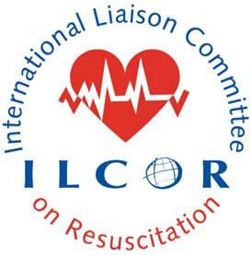 This document provides a checklist of requirements to guide lead authors, Task Force chairs and members and Scientific Advisory Committee (SAC) members on the Task Force(s) in the preparation of the CoSTR and EtD. This checklist should be completed by the lead author and checked by the SAC rep on the Task Force. Once this checklist is completed and all requirements are met the SAC rep submits the final CoSTR and EtD and checklist to the SAC chair. The SAC chair or delegate may assign the CoSTR and EtD to a SAC member who is not involved in the writing group or taskforce(s) to independently review the CoSTR. This process provides independent peer review prior to upload to ILCOR.org and formative peer feedback to members of SAC. The SAC chair or delegate will post the CoSTR and EtD on ILCOR.org.
.

ILCOR CoSTR Content Checklist

CoSTR Title: EIT 6105: Targeted BLS training for likely rescuers of high-risk populations: An Adolopment Systematic Review
Lead Author: Kevin NATION
Date CoSTR received: 10 Dec 2025
Date SAC member completed checklist review: 14 Dec 2025
SAC member: Judith FINN
SAC member recommendation that independent SAC peer review would be helpful: N/A

Each CoSTR should comply with the current version of the CoSTR template and instructions document and the authorship guidelines and the publication process and output (ilcor.org)

Disclaimer for why CoSTR is marked ‘DRAFT’

CoSTR Citation

Methodological introduction

Citation for systematic review and link to Pubmed (when available) including original systematic review if this is an adolopment SR

Inclusion of PICOST – comply with the version approved by TF

Inclusion of PROSPERO registration number (if adolopment SR include the original SR’s registration number with PROSPERO if it was originally registered)

Consensus on science

Treatment recommendations

Justification and technical remarks – narrative reporting of EtD Framework incorporating values and preferences

Knowledge gaps in correct format

References listed alphabetically as per format

List of authors / collaborators approved by TF chair following CEE publication documents on ILCOR.org

Collaborator emails of approval included with submission, verifying compliance with publication policy

Conflict of interest is declared

All relevant Evidence to Decision Tables are included

Reviewer notes:
Reviewed and approved – pending a couple of minor referencing issues.

