Tables and Figures
Figure 1: PRISMA Flow Diagram
Studies included in review
(n = 20)
Reports excluded:
Not original research (n = 26)
Not relevant to resuscitation training (n = 36)
Not RCT (n=35)
Reports excluded:
Not original research (n = 2)
Not relevant to resuscitation training (n = 4)
Not RCT (n=4)
Records identified from:
Databases (n = 9756)
Records removed before screening:
Duplicate records removed
(n = 3440)
Records screened
(n = 6316)
Records excluded
(n = 6201)
Reports sought for retrieval
(n = 115 )
Reports not retrieved
(n = 0)
Reports assessed for eligibility
(n = 115)
Records identified from:
Updated searching (n = 876)
Reports assessed for eligibility
(n = 12)
Identification of studies via databases
Identification of studies via other methods
Identification
Screening
Included
Reports sought for retrieval
(n = 12)
Reports not retrieved
(n = 0)
Records excluded
(n = 864)

Table 1: Risk of bias assessment (RCT)
Study | Randomization | Deviations from  intended intervention | Outcome data  missing | Measurement of outcome | Selection of  reported results | Overall
Allan 2013 | Unclear | Low | Low | Low | Low | Some
Cortegiani 2017 | Low | Low | Low | Low | Low | Minor
Ghaderi 2023 | High | Low | Low | Low | Low | Serious
Gonzalez-Santano 2020 | Unclear | Low | Low | Low | Low | Some
Jang 2020 | Low | Low | Low | Low | Low | Minor
Jiang 2024 | Low | Low | Low | Low | Low | Minor
Kardong-Edgren 2010 | Unclear | Low | Low | Low | Low | Some
Katipoglu 2021 | Unclear | Unclear | Low | Low | Low | Some
Kong 2020 | Low | Low | Low | Low | Low | Minor
Labuschagne 2022 | Low | Low | Low | Low | Low | Minor
Lee 2023 | Low | Low | Unclear | Low | Low | Some
Lin 2018 | Low | Low | Low | Low | Low | Minor
Meng 2021 | Low | Low | Low | Low | Low | Minor
Min 2016 | High | Low | Low | Low | Low | Serious
Pavo 2016 | Low | Low | Low | Low | Unclear | Some
Spooner 2007 | Unclear | Low | Unclear | Low | Unclear | Serious
Suet 2020 | Unclear | Low | Low | Low | Low | Some
Sutton 2011 | Unclear | Low | Low | Low | Low | Some
Wagner 2019 | Low | Low | Low | Low | Low | Minor
Zhou 2020 | Unclear | Low | Low | Low | Low | Some

Figure 2: Forest plot - the effect feedback device during training on mean compression depth
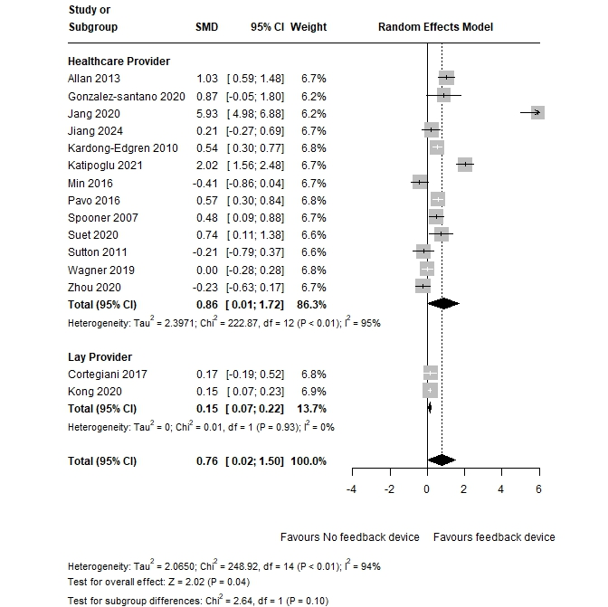
Note: Fifteen randomized controlled trials (RCTs) with a total of 4,185 participants (2,189 in the non-feedback group and 1996 in the feedback group) evaluated the effect of CPR feedback devices on objectively measured mean compression depth. The results indicated that participants trained with feedback devices had significantly greater mean compression depth compared to those trained without them (SMD = 0.76, 95% CI: 0.02–1.52, p = 0.04, I²=94%). Subgroup analysis showed that the difference in effect size between healthcare providers (HCPs) and lay providers were not statistically significant (HCP: 0.86 vs Lay Provider 0.15, p=0.10).
Figure 3: Forest plot - effect of CPR feedback device during training on compression depth compliance
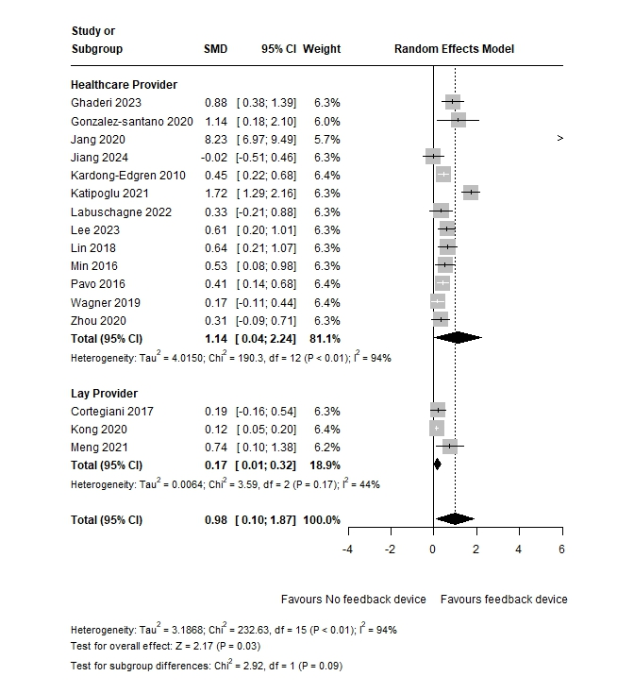
Note: sixteen other RCTs involving 4,304 participants (2,272 in the non-feedback group and 2,032 in the feedback group) examined the effect of CPR feedback devices during resuscitation training on compression depth compliance. The results showed that using CPR feedback devices during training had a large impact on depth compliance (SMD = 0.98, 95% CI: 0.10–1.89, p = 0.03, I² = 94%). Subgroup analysis showed that the difference in effect size between healthcare providers (HCPs) and lay providers were not statistically significant (SMD: HCP 1.14 vs Lay provider 0.17, p=0.09).

Figure 4: Forest plot - effect of feedback device during training on mean compression rate
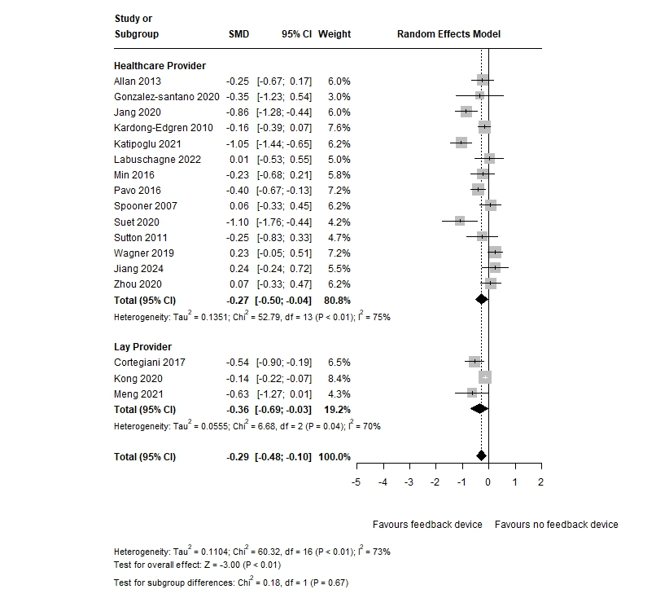
Note: Seventeen randomized controlled trials (RCTs) involving a total of 4,327 participants (2,286 in the non-feedback group and 2,041 in the feedback group) evaluated the effect of CPR feedback devices on objectively measured mean compression rate. The results indicated that participants trained with feedback devices had a significantly lower mean compression rate compared to those trained without them, as participants in the non-feedback group tended to compress too quickly (>120 bpm) (SMD = -0.29, 95% CI: -0.48 to -0.10, p < 0.01, I² = 73%). There was no significant difference in effect between healthcare providers and lay providers (SMD: HCP -0.27 vs lay provider -0.36, p = 0.67).

Figure 5: Forest plot - effect of CPR feedback device during training on compression rate compliance
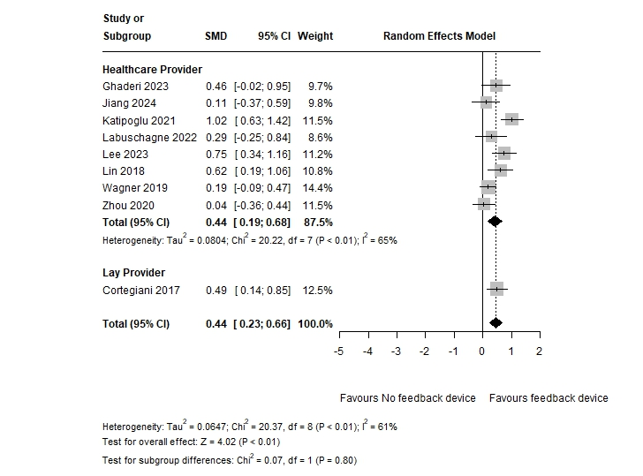

Notes: Nine RCTs involving 905 participants (460 in the non-feedback group and 445 in the feedback group) examined the effect of CPR feedback devices during resuscitation training on compression rate compliance. The results demonstrated that using CPR feedback devices during training had a substantial impact on rate compliance (SMD = 0.45, 95% CI: 0.23–0.67, p < 0.01, I² = 61%). The effect of the feedback device on rate compliance was not statistically significant between HCPs and lay providers (SMD HCP 0.44 vs Lay provider 0.49, p = 0.80).

Figure 6: Forest plot – effect of feedback device during training on chest compression recoil
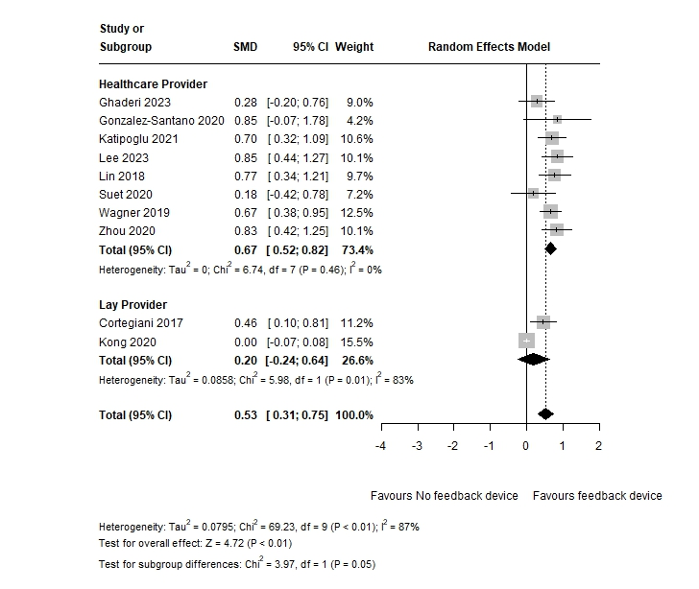
Note: Ten randomized controlled trials (RCTs) involving a total of 3,496 participants (1,803 in the non-feedback group and 1,693 in the feedback group) evaluated the effect of CPR feedback devices during training on chest recoil. The results demonstrated that using CPR feedback devices during training had a significant impact on recoil compliance (SMD = 0.53, 95% CI: 0.31 to 0.75, p < 0.01, I² = 87%).
The effect of feedback device during training was significantly different between HCPs and lay providers. In HCPs, the use of feedback devices during training signficantly improve the recoil compliance (SMD 0.67, 95%CI: 0.52-0.82). However, it did not yield statistical significance in lay providers (SMD 0.20, 95%CI: -0.24 to 0.64). The difference in effect size between HCPs and lay providers were statisticallfy significant (p = 0.05)

Figure 7: Forest plot – effect of feedback device during training on overall CPR score (measured by computer software)
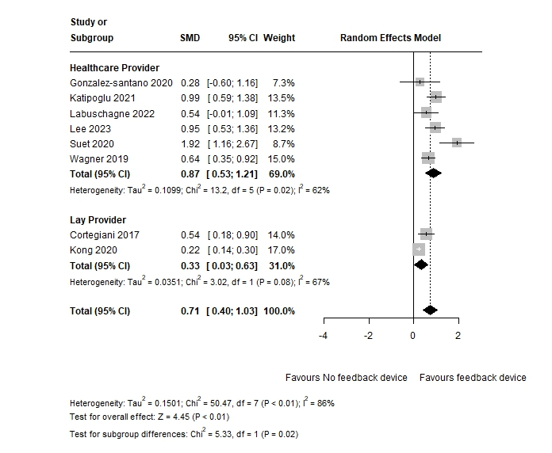
Note: Eight RCTs involving a total of 3261 participants (1687 in the non-feedback group and 1574 in the feedback group) evaluated the effect of CPR feedback devices on overall CPR quality during resuscitation training. Quality was assessed by computer software integrating all three metrics of chest compression (depth, rate and recoil) with limited validity evidence. The results showed that the use of feedback devices significantly improved the overall quality of CPR, with a pooled effect size of 0.71 (95% CI: 0.40–1.03, p < 0.01,I² = 86%). The effect size of feedback devices during training was signficantly higher in HCPs than in lay providers (SMD HCP 0.87 vs Lay provider 0.33, p = 0.02).

Figure 8: Forest plot – effect of CPR feedback device during training on overall CPR quality
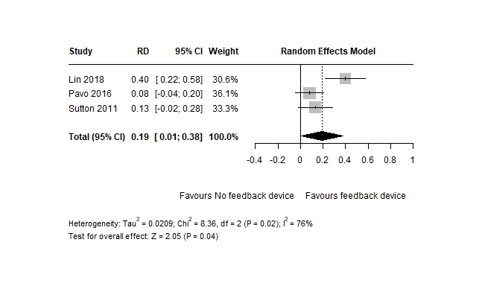

Note: Three randomized controlled trials (RCTs) involving a total of 349 participants (178 in the non-feedback group and 171 in the feedback group) evaluated the effect of CPR feedback devices on overall CPR quality during resuscitation trainingThe results showed that the use of feedback devices significantly improved the overall quality of CPR, with a pooled risk difference (RD) of 0.19 (95% CI: 0.01 to 0.38, p = 0.04,I² = 76%).

