Question
Should a windlass tourniquet compared with no tourniquet or another tourniquet design be used for control of life-threatening extremity bleeding in children?
Population: | Children under 19 years of age
Intervention: | Windlass or other design of tourniquet
Comparison: | No tourniquet
Main outcomes: | Critical: Cessation of bleeding in upper extremities; Cessation of bleeding in lower extremities; Important: Adverse events. Surrogate outcome for cessation of bleeding is obliteration of doppler pulses in extremities.
Setting: | Healthcare facility or prehospital setting
Perspective: | PreshopitalIRST AID OR PREHOSPITAL CARE PROVIDER
Background: | A systematic review was completed in 2020 on control of life-threatening bleeding in adults and children. Minimal evidence was identified regarding use of a tourniquet in children. Tourniquets are designed for adults and child-specific tourniquets not yet available. A scoping review on this topic identified experimental studies using manikins or PVC pipes, suggesting failure to tighten appropriately on models of small circumference. A systematic review was undertaken to evaluate all evidence from studies performed in children.
Conflict of interests: | NPC, CG, ES and DZ are authors of the systematic review on control of life-threatening bleeding {Charlton 2020 1}

Assessment

Problem
Is the problem a priority?
Judgement | Research evidence | Additional considerations
○ No  ○ Probably no  ● Probably yes  ○ Yes  ○ Varies  ○ Don't know | In 2016, 1,065 children succumbed to injuries sustained in motor vehicle collisions, 187 died after having been struck by a vehicle, and 71 perished due to lacerations. {Ross 2018} Unintentional injury remains the leading cause of death for pediatric persons ages 0–19 years and over 600 children die annually as a result of gun violence. {Gonzalez 2015 4} Military studies have suggested that tourniquets are life-saving in pediatric traumatic extremity injuries. {Sokol 2015 983, Kragh 2012 1361} In addition, pediatric trauma societies recommend the use of tourniquets for life-threatening extremity bleeding the in the pediatric population. {Bobko 2013 94, Cunningham 2018 665} | While pediatric severe limb bleeding is not as frequent as in adults when it occurs, its implications are significant.

Desirable Effects
How substantial are the desirable anticipated effects?
Judgement | Research evidence | Additional considerations
○ Trivial  ○ Small  ● Moderate  ○ Large  ○ Varies  ○ Don't know | Two observational studies enrolling children ages 2 to 16 years demonstrated Doppler occlusion of distal pulses in 71/71 upper extremities and 69/73 lower extremities with use of a windlass tourniquet (specifically the Combat Application Tourniquet). {Harke 2019 e20183447, Kelly 2020 644} Participants did not have active bleeding and occlusion of pulses was used as a surrogate outcome for cessation of bleeding. There were no controls so it is unclear how this would relate to direct pressure alone. In addition, prior observational studies performed in adults also demonstrate an improvement in survival with tourniquet use. {Charlton 2020 1}  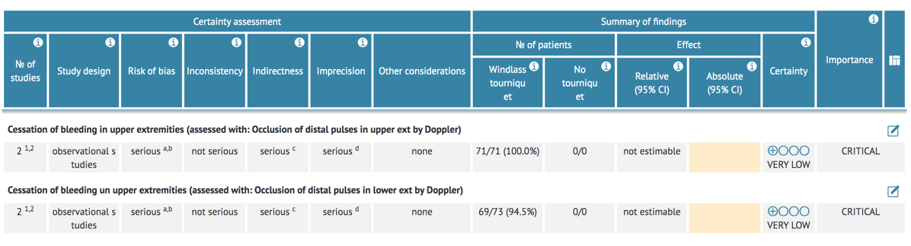

Undesirable Effects
How substantial are the undesirable anticipated effects?
Judgement | Research evidence | Additional considerations
○ Large  ○ Moderate  ● Small  ○ Trivial  ○ Varies  ○ Don't know | Pain limiting application of the tourniquet was a factor in 1 child (1 tourniquet application of 120 total applications) reported in one study. {Kelly 2020 644} Prior adult studies do not demonstrate a difference in significant side effects for those who had a tourniquet placed compared with those that did not have a tourniquet placed. {Charlton 2020 1}  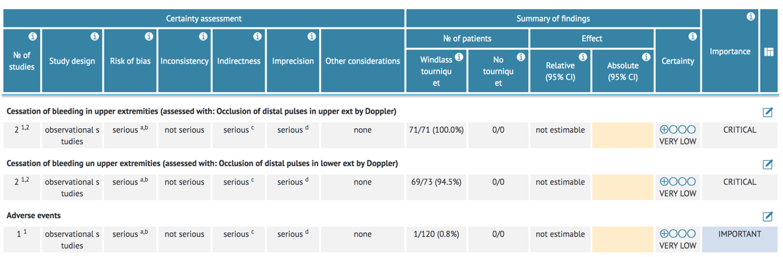 | Pain is an anticipated adverse effect from tourniquet application but led to premature removal in one child. This was treated as a tourniquet failure.

Certainty of evidence
What is the overall certainty of the evidence of effects?
Judgement | Research evidence | Additional considerations
● Very low  ○ Low  ○ Moderate  ○ High  ○ No included studies | Very low certainty evidence from observational studies, downgraded for bias, indirectness and imprecision. {Harke 2019 e20183447, Kelly 2020 644} Addition data extrapolated from adult studies. {Charlton 2020 1}

Values
Is there important uncertainty about or variability in how much people value the main outcomes?
Judgement | Research evidence | Additional considerations
○ Important uncertainty or variability  ○ Possibly important uncertainty or variability  ● Probably no important uncertainty or variability  ○ No important uncertainty or variability | No relevant studies | While no relevant studies were identified, it is likely that stakeholders would value the ability to control severe, life-threatening limb bleeding in a pediatric patient.

Balance of effects
Does the balance between desirable and undesirable effects favor the intervention or the comparison?
Judgement | Research evidence | Additional considerations
○ Favors the comparison  ○ Probably favors the comparison  ○ Does not favor either the intervention or the comparison  ● Probably favors the intervention  ○ Favors the intervention  ○ Varies  ○ Don't know | No relevant studies | While there are no relevant studies available for comparison, the studies in this review demonstrate occlusion of distal pulses with the use of a CAT windlass tourniquet. The only adverse event in these studies was pain, limiting application in 1 child. {Kelly 2020 644} Adult studies demonstrate improvement in patient outcome with no increase in adverse events. {Charlton 2020 1}

Resources required
How large are the resource requirements (costs)?
Judgement | Research evidence | Additional considerations
○ Large costs  ○ Moderate costs  ○ Negligible costs and savings  ○ Moderate savings  ○ Large savings  ● Varies  ○ Don't know | Per online stores:  United States Cost:  Generation 7 CAT is $25-35 US  SOFT-T $32.95  SWAT-T $11.95  South African cost:  CAT - R1034.68 = $56  SWAT T - R259 = $14 US  Australian cost:  CAT—T approx $65 AUD  SOF-T approx $45 AUD | The cost is variable depending on the product but can range from $15-$40 USD. Specifically, the CAT Gen 7 can cost between $25-$35 USD. This represents a significant amount of money in some geographic regions. However, the potential decrease in the need for blood transfusion, length of ICU stays, or lost productivity due to preventable mortality could vastly offset this expense.

Certainty of evidence of required resources
What is the certainty of the evidence of resource requirements (costs)?
Judgement | Research evidence | Additional considerations
● Very low  ○ Low  ○ Moderate  ○ High  ○ No included studies | No relevant studies | All data gathered was from online information of average cost of the products per region.

Cost effectiveness
Does the cost-effectiveness of the intervention favor the intervention or the comparison?
Judgement | Research evidence | Additional considerations
○ Favors the comparison  ○ Probably favors the comparison  ○ Does not favor either the intervention or the comparison  ● Probably favors the intervention  ○ Favors the intervention  ○ Varies  ○ No included studies | No relevant studies | There are no available studies to compare the cost effectiveness of manufactured tourniquets compared with direct manual compression on an individual or population level. However, it was felt by the task force that the benefit of saving a life would outweigh the cost of a tourniquet.

Equity
What would be the impact on health equity?
Judgement | Research evidence | Additional considerations
○ Reduced  ○ Probably reduced  ○ Probably no impact  ○ Probably increased  ○ Increased  ● Varies  ○ Don't know | No relevant studies | As with most medical devices, lower socioeconomic groups can experience a reduction in health equity due to the cost of manufactured tourniquets. While on both an individual and population level, the cost of a tourniquet is more than the use of direct manual pressure and in some instances the cost may impair purchase, the potential decrease in the need for blood transfusion, length of ICU stays, or lost productivity due to preventable mortality could vastly offset this expense.

Acceptability
Is the intervention acceptable to key stakeholders?
Judgement | Research evidence | Additional considerations
○ No  ○ Probably no  ● Probably yes  ○ Yes  ○ Varies  ○ Don't know | No relevant studies | Despite the additional expense and training requirements associated with use of a tourniquet, and despite the adverse effect of pain, the task force consensus is that because of its potential life-saving benefits, most stakeholders would consider tourniquets to be an acceptable intervention.

Feasibility
Is the intervention feasible to implement?
Judgement | Research evidence | Additional considerations
○ No  ○ Probably no  ○ Probably yes  ○ Yes  ● Varies  ○ Don't know | No relevant studies | Feasibility would likely vary based upon cost of the tourniquet and resources available. This likely varies on region.  Training costs would also vary and depend on the modality used, the training apparatus, and course fees.

Summary of judgements
 | Judgement
Problem | No | Probably no | Probably yes | Yes |  | Varies | Don't know
Desirable Effects | Trivial | Small | Moderate | Large |  | Varies | Don't know
Undesirable Effects | Large | Moderate | Small | Trivial |  | Varies | Don't know
Certainty of evidence | Very low | Low | Moderate | High |  |  | No included studies
Values | Important uncertainty or variability | Possibly important uncertainty or variability | Probably no important uncertainty or variability | No important uncertainty or variability
Balance of effects | Favors the comparison | Probably favors the comparison | Does not favor either the intervention or the comparison | Probably favors the intervention | Favors the intervention | Varies | Don't know
Resources required | Large costs | Moderate costs | Negligible costs and savings | Moderate savings | Large savings | Varies | Don't know
Certainty of evidence of required resources | Very low | Low | Moderate | High |  |  | No included studies
Cost effectiveness | Favors the comparison | Probably favors the comparison | Does not favor either the intervention or the comparison | Probably favors the intervention | Favors the intervention | Varies | No included studies
Equity | Reduced | Probably reduced | Probably no impact | Probably increased | Increased | Varies | Don't know
Acceptability | No | Probably no | Probably yes | Yes |  | Varies | Don't know
Feasibility | No | Probably no | Probably yes | Yes |  | Varies | Don't know

Type of recommendation
Strong recommendation against the intervention | Conditional recommendation against the intervention | Conditional recommendation for either the intervention or the comparison | Conditional recommendation for the intervention | Strong recommendation for the intervention
○ | ○ | ○ | ● | ○

Conclusions

Recommendation
We suggest the use of a manufactured windlass tourniquet for the management of life-threatening extremity bleeding in children (weak recommendation, very low certainty of evidence).

We are unable to recommend for or against other tourniquet types in children due to lack of evidence.

For infants and children with extremities that are too small to allow the snug application of a tourniquet before activating the circumferential tightening mechanism, we recommend the use of direct manual pressure with or without the application of a hemostatic trauma dressing. (Good Practice Statement)

Technical Remarks:

In both studies included, the Combat Application Tourniquet Generation 7 was the specific brand of windlass rod tourniquet used.

The included studies evaluated tourniquet use on children from 2 years to 16 years of age with a minimal limb circumference fo 13 cm.

For the purpose of this review, the pediatric age of 18 and younger was chosen by the First Aid and Pediatrics Task Forces and is the same as used in a previous scoping review by ILCOR.

Justification
In making this recommendation, the First Aid Task force considered the following:
· There is a lack of direct evidence demonstrating that tourniquets are a life-saving treatment for life-threatening bleeding in children. However, the First Aid Task Force values the previously established role of a manufactured windlass tourniquet in reducing mortality in adults with life-threatening bleeding. {Charlton 2020 1} The Task Force relied heavily on these adult studies to infer that tourniquets would also be lifesaving for life-threatening bleeding in children.
· There is a lack of direct comparative evidence for the best tourniquet types in children and infants. In formulating treatment recommendations, the Task Force relied on data from two observational studies in healthy pediatric participants. {Harke 2019 e20183447, Kelly 2020 644}. In these studies, a windlass rod style tourniquet, specifically the Combat Application Tourniquet Generation 7 in both studies, was able to occlude distal blood flow in both the upper and lower extremities in children as young as two years of age with a minimum limb circumference of 13 cm.
· In the two studies included, the Combat Application Tourniquet Generation 7 was the specific brand of windlass rod tourniquet used. Other windlass rod tourniquets may vary in their ability to tighten successfully in small limb diameters. While some data is available from manikin studies, these studies were felt to be too indirect to include. {El-Sherif 2019 361, Kragh 2019 41} In accordance with the 2020 CoSTR recommendations for adult severe, life threatening extremity bleeding: “we suggest direct manual pressure with or without use of a hemostatic dressing if the site of bleeding is not amenable to use of a tourniquet.” {Singletary 2020 S284, Singletary 2020 A240 }
· There is no human evidence for the use of either manufactured or improvised tourniquets in children less than 2 years of age. It is the expert opinion of the Task Force that for children less than two years of age, body size and a lower relative pressure would likely make direct manual pressure more efficacious than in adults. Therefore, direct pressure should be used to treat life-threatening extremity bleeding in children less than 2 years of age. Based on extrapolation from adult literature, this should be applied with a hemostatic dressing, if available. {Charlton 2020 1} While it may be difficult for providers to determine whether a child is two years or older, the Task Force discussed that the typical habitus of a toddler, rather than an infant could be used to help make this determination.
· The only adverse effect reported was pain in one child in one study. {Harke 2019 e20183447} This is consistent with studies of adult tourniquets and is an expected effect of tourniquet application {Charlton 2020 1}.
· Inflicting pain in a volunteer study in the pediatric population would be unethical, and therefore, understandably there was a failure of the application of the tourniquet to occlude distal pulses in this study as the force required to do so could cause pain {Harke 2019 e20183447}. The Task Force acknowledges that the survival benefit of tourniquet use in life-threatening bleeding outweighs the risk of pain in both pediatric and adult populations.

Subgroup considerations

Implementation considerations

Monitoring and evaluation

Research priorities
· There is an urgent need for comparative RCTs in the prehospital setting to determine which tourniquet designs produce beneficial outcomes in the pediatric population
· Additional human studies are needed to determine both the lower age and size limits in which these tourniquets can be applied to both upper and lower extremities to enable hemorrhage control
· Studies are needed to identify all the complications of tourniquet use in children
· Further studies are needed to determine the efficacy and rapidity of application of tourniquets on children by first aid providers.

References Summary
1. Ross EM, Bolleter S,Simon E,Kharod CU. Pediatric Extremity Hemorrhage and Tourniquet Use. Journal of Emergency Medical Services; 2018. Available at: https://www.jems.com/patient-care/trauma/pediatric-extremity-hemorrhage-and-tourniquet-use/ Accessed 1/21/2020.
2. Gonzalez KW, Desai AA, Dalton BG, Juang D. Hemorrhagic Shock. J Pediatr Intensive Care. 2015 Mar;4(1):4-9. doi: 10.1055/s-0035-1554982. PMID: 31110843; PMCID: PMC6513149.
3. Sokol KK, Black GE, Azarow KS, Long W, Martin MJ, Eckert MJ. Prehospital interventions in severely injured pediatric patients: Rethinking the ABCs. J Trauma Acute Care Surg. 2015 Dec;79(6):983-9; discussion 989-90. doi: 10.1097/TA.0000000000000706.
4. Kragh JF Jr, Cooper A, Aden JK, Dubick MA, Baer DG, Wade CE, Blackbourne LH. Survey of trauma registry data on tourniquet use in pediatric war casualties. Pediatr Emerg Care. 2012 Dec;28(12):1361-5. doi: 10.1097/PEC.0b013e318276c260.
5. Bobko J, Lai TT, Smith ER, Shapiro GL, Baldridge RT, Callaway DW. Tactical emergency casualty care - pediatric appendix: novel guidelines for the care of the pediatric casualty in the high-threat, prehospital environment. J Spec Oper Med. 2013 Winter;13(4):94-107.
6. Cunningham A, Auerbach M, Cicero M, Jafri M. Tourniquet usage in prehospital care and resuscitation of pediatric trauma patients-Pediatric Trauma Society position statement. J Trauma Acute Care Surg. 2018 Oct;85(4):665-667. doi: 10.1097/TA.0000000000001839.
3. Harcke HT, Lawrence LL, Gripp EW, Kecskemethy HH, Kruse RW, Murphy SG. Adult Tourniquet for Use in School-Age Emergencies. Pediatrics. 2019 Jun;143(6):e20183447. doi: 10.1542/peds.2018-3447. Epub 2019 May 7. PMID: 31064797.
4. Kelly JR, Levy MJ, Reyes J, Anders J. Effectiveness of the combat application tourniquet for arterial occlusion in young children. J Trauma Acute Care Surg. 2020 May;88(5):644-647. doi: 10.1097/TA.0000000000002594. PMID: 31977996.
5. Charlton NP, Swain JM, Brozek JL, Ludwikowska M, Singletary E, Zideman D, Epstein J, Darzi A, Bak A, Karam S, Les Z, Carlson JN, Lang E, Nieuwlaat R. Control of Severe, Life-Threatening External Bleeding in the Out-of-Hospital Setting: A Systematic Review. Prehosp Emerg Care. 2020 Apr 27:1-33. doi: 10.1080/10903127.2020.1743801. Epub ahead of print. PMID: 32208060.

