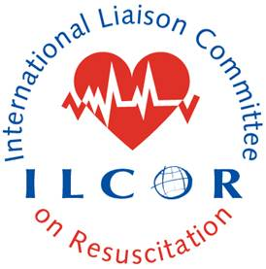

## Consensus on Science with Treatment Recommendations (COSTR)



**Figure: Modified flow diagram of number of studies and infants included for each specified outcome for infants who had resuscitation continued beyond 10 minutes. Moderate to severe neuroimpairment was defined by each study.**